2021 National Disability Employment Awareness Month

Social Media Toolkit
  - October 2021
The Department of Labor’s 2021 theme for National Disability Employment Awareness Month (NDEAM) is “America’s Recovery: Powered by Inclusion.” Their website states that it “hopes the theme will reflect the importance of ensuring that people with disabilities have full access to employment and community involvement during the national recovery from the COVID-19 pandemic.” This October, we invite the Protection and Advocacy network to add a caret mark to the theme, to read “America’s Recovery: Powered by Competitive and Integrated Inclusion.
To that end, here are some resources focusing on eliminating the subminimum wage, and supporting competitive, integrated employment.

Sample Tweets
It is time we eliminate subminimum wages for people with disabilities. It is time to #PhaseOut14c of the Fair Labor Standards Act. It’s time for true fairness. #NDEAM2021
Every person, regardless of disability, deserves an opportunity for meaningful employment. Right now, subminimum wages are still legal in the U.S. We must take action to #PhaseOut14c https://ndrn.salsalabs.org/realjobsfairpay/
FACT: In the U.S., workers with disabilities can legally be paid less than the minimum wage. Some subminimum wages are as low as $2/day. It’s time to #PhaseOut14c
We know a better future is possible for workers with disabilities. Let’s pull together and eliminate subminimum wages for people with disabilities. We must #PhaseOut14c and demand competitive intergrated employment for all.
Supported employment, customized employment and competitive employment are all ways individuals with even the most significant disabilities can become employed. We must #PhaseOut14c
Let’s take action together to #PhaseOut14c and demand the elimination of subminimum wages for workers with disabilities https://ndrn.salsalabs.org/realjobsfairpay/
Internships and work experiences help individuals gain experience, skills and work values. People with disabilities need the same opportunity and respect that is granted to others in work related job experiences. #PhaseOut14c
“You will find that once people with disabilities get into the real business setting or the real you know job setting that they have skills far beyond what anybody imagined” – Cheryl Bates Harris of @NDRNadvocates https://www.ndrn.org/resource/panda-pod-episode-10/
“Do we really in the year 2021 want to continue to use federal dollars to basically keep people in poverty by segregating them and holding them to a low standard of behavior or expectation?” – Cheryl Bates Harris of @NDRNadvocates https://www.ndrn.org/resource/panda-pod-episode-10/

Tweet at your elected official:
[TWITTER HANDLE] We need your help to #PhaseOut14c so people with disabilities can have the same opportunity and respect in the workplace as everyone else.
[TWITTER HANDLE] Paying people subminimum wages under Section 14c of the Fair Labor Standards Act is outdated and discriminatory. Will you help #PhaseOut14c?
[TWITTER HANDLE] All people deserve the opportunity to earn a fair wage. Right now, people with disabilities get subminimum wages because of FLSA’s Section 14(c). Can you support #PhaseOut14c?

Resources
NDRN’s National Disability Employment Awareness Month Page
Competitive Integrated Employment Coalition Website
The Dignity of Work: PandA Pod, Episode 10
Transformation to Competitive Integrated Employment Act Action Alert

Graphics for Download
Subminimum wages awareness graphics by AAPD 2020 Intern Cohort (Credit: Katy Brenna, @katy_Brennan7)

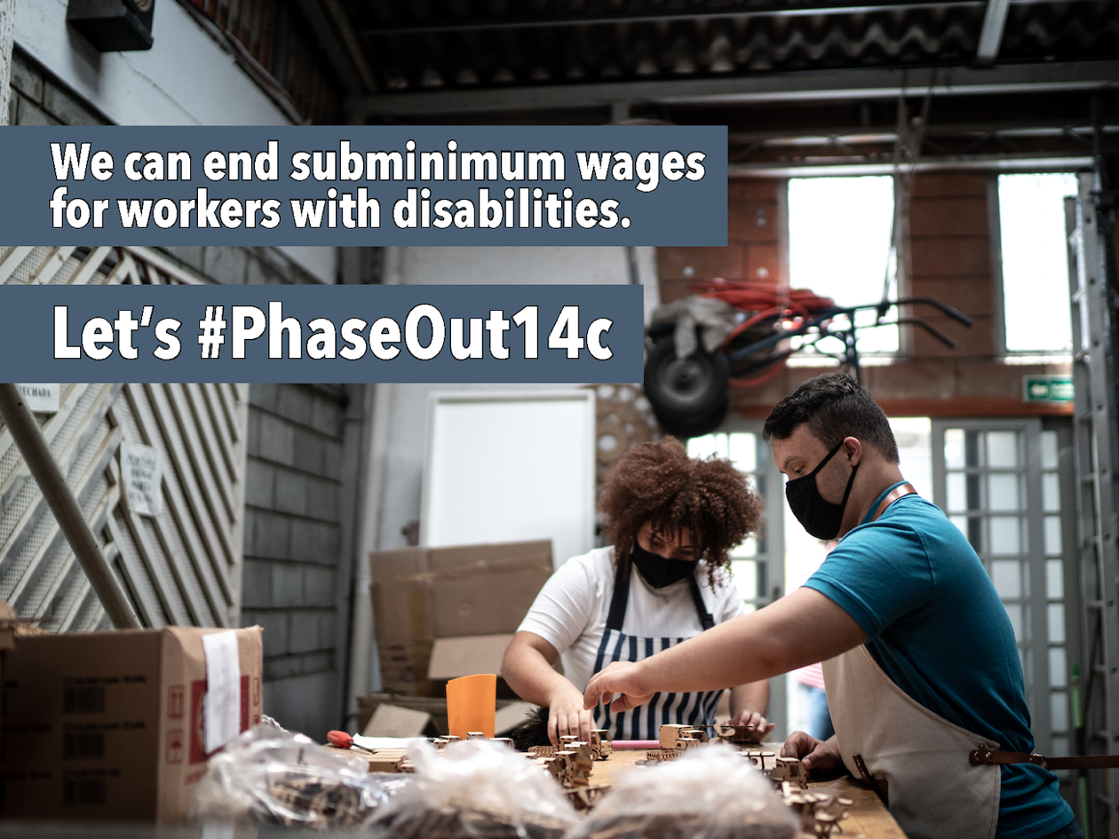

Image description: Two workers in a sheltered setting wear masks and work on sorting wooden pieces. Text reads: We can end subminimum wages for workers with disabilities. Let’s #PhaseOut14c

