June 22, 2021

Dear Representative Beyer:

On behalf of the National Disability Rights Network (NDRN), I would like to thank you for the role you played in the creation and passage of the COVID-19 Hate Crime Act. With the unfortunate rise in hate crimes in the United States over the last year or so, it is pivotal that our country take steps to equip law enforcement and communities with tools to better understand and then combat hate crimes. NDRN has followed and supported the bill since the original introduction of the Khalid Jabara and Heather Heyer National Opposition to Hate, Assault, and Threats to Equality (Jabara-Heyer NO HATE) Act. We are excited to see what the bill has become and the powerful impact it will have on fighting hate crime.

NDRN is the voluntary membership association for Protection and Advocacy (P&A) agencies. The P&A agencies are a nationwide network of congressionally mandated, cross disability organizations operating in every state, the District of Columbia, Puerto Rico, and the U.S. Territories (American Samoa, Guam, Northern Mariana Islands, and the US Virgin Islands). There is also a P&A affiliated with the Native American Consortium which includes the Hopi, Navajo, and San Juan Southern Paiute Nations located in the Four Corners region of the Southwest.

NDRN stands as an ally with all minority groups when fighting back against discrimination and violence. Unfortunately, people with disabilities are regularly the targets of hate crimes themselves. Consequently, the nationwide P&A network works to advocate against hate crimes. NDRN believes this legislation will help to bring about improvements in the understanding of hate crimes and the provision of services for hate crime witnesses and survivors in the United States.

Again, NDRN celebrates the passage of the COVID-19 Hate Crimes Act and thanks you for the significant work you did to bring about this legislation.

Sincerely,
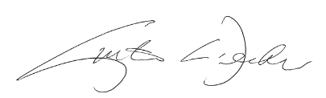
Curtis L. Decker
Executive Director
National Disability Rights Network

