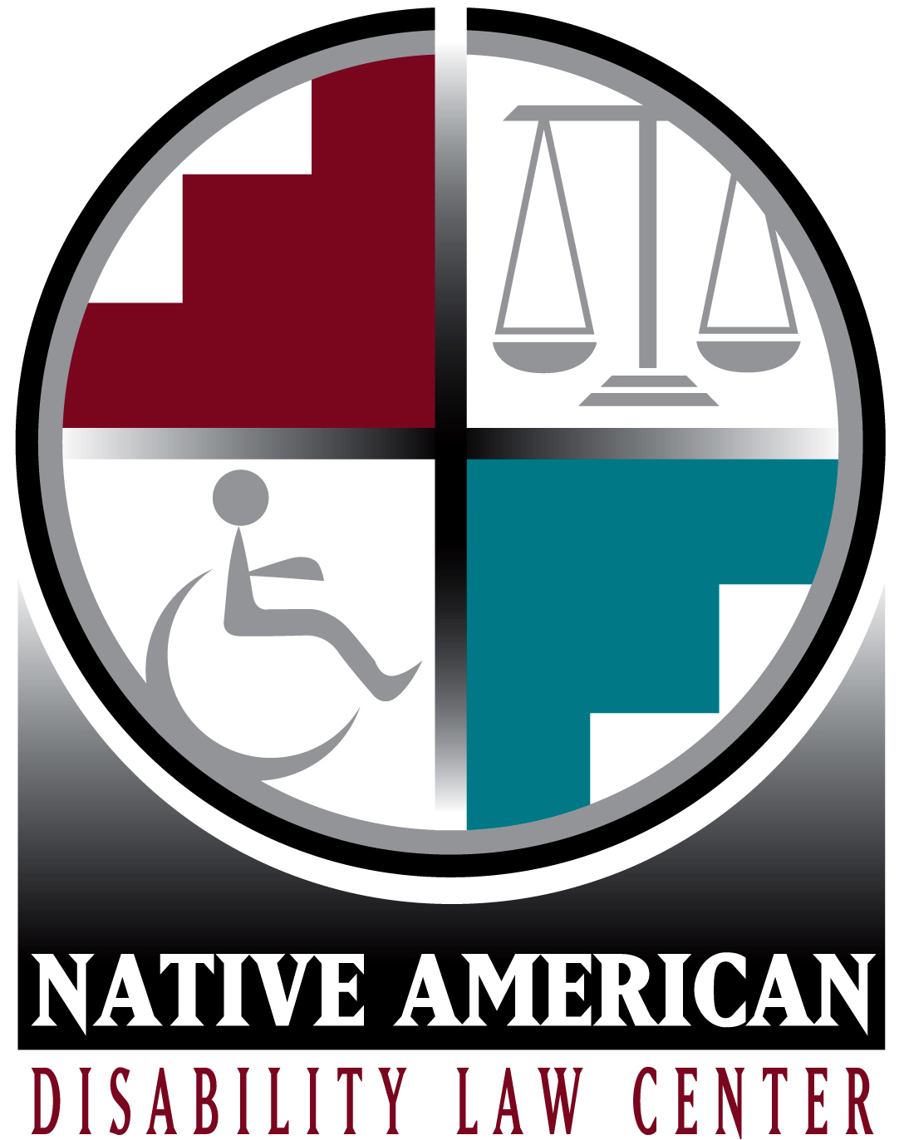 July 24, 2020

Therese E. Yanan
Attorney at Law
Executive Director

Submitted via Electronic Mail BrokenPromises@usccr.gov

OCRE/Public Comments
U.S. Commission on Civil Rights
1331 Pennsylvania Avenue, NW, Suite 1150
Washington, DC 20425

Re: U.S. Commission on Civil Rights Public Briefing: “COVID-19 in Indian Country: The Impact of Federal Broken Promises on Native Americans”

Dear Members of the Commission on Civil Rights:

On behalf of the Native American Disability Law Center (Law Center), North Dakota Protection & Advocacy Project, and the National Disability Rights Network (NDRN), we commend the Commission for conducting the briefing on Friday, July 17, 2020 regarding the impact of the COVID-19 health crisis in Indian Country. We wish to submit this letter as public comments for consideration as you prepare your report.

The Law Center is a cross-disability non-profit law firm designated by the Navajo Nation and Hopi Governments as the Protection and Advocacy (P&A) organization for their communities. The Law Center is part of the federally mandated P&A system and was created to address the unique legal issues facing Native Americans with disabilities. It is specifically authorized to pursue legal, administrative, and other appropriate remedies to protect and advocate for the rights of Native Americans with disabilities.

North Dakota Protection & Advocacy Project is a cross-disability organization designated as the P&A organization for North Dakotans with disabilities. It is also part of the federally mandated P&A system and is specifically authorized to pursue legal, administrative, and other appropriate remedies to protect and advocate for the rights of North Dakotans with disabilities, including a sizable Native American population.

NDRN is the non-profit membership organization for the P&A agencies and Client Assistance Program (CAP) systems for individuals with disabilities. The P&As and CAPs were established by the United States Congress to protect the rights of people with disabilities and their families through legal support, advocacy, referral, and education. P&As and CAPs are in all 50 states, the District of Columbia, Puerto Rico, and the US territories (American Samoa, Guam, Northern Mariana Islands, and the US Virgin Islands), along with the Law Center P&A. Collectively, the P&A and CAP Network is the largest provider of legally based advocacy services to people with disabilities in the United States.

It is important to keep in mind that Native Americans with disabilities often experience race- and disability-based discrimination. They frequently get caught in the quagmire of tribal, state and federal programs that ostensibly were created to serve Indian Country, and specifically Native Americans. However, these programs often lack the services and supports needed for Native Americans with disabilities to utilize these benefits. Many Native Americans with disabilities depend on the support and assistance of their family, increasingly so during this time of radically increased isolation and stress. Lacking such support networks, Native Americans with disabilities are at extreme risk. Any improvement in Native American community resources or infrastructure, necessarily improves supports and services for Native Americans with disabilities.

The following comments result from our experience in our primary service area of the Four Corners (Southwest Colorado, Northwest New Mexico, Northern Arizona, and Southeast Utah) as well as input from our colleagues at P&As agencies across the country and NDRN.
- Broken Promises found that Native Americans experience distinct health disparities as compared to other Americans which are compounded by Native American healthcare programs being chronically underfunded. How has the outbreak of COVID-19 impacted these health disparities?
The COVID-19 health crisis has hit Indian County especially hard. In New Mexico, where Native Americans make up roughly 10% of the population, as of July 15, 2020, they represent over 40% of the state’s coronavirus cases. The existing healthcare disparities were exacerbated as the virus spread through Native communities. Heart disease, diabetes, and malignant neoplasm are leading causes of death among American Indian and Alaska Native populations and this population continues to die at higher rates than other Americans in many categories, including chronic liver disease. These disparities are of particular concern in the context of COVID-19 given that people with these conditions are generally at an increased risk of severe illness from COVID-19. Additionally, individuals with disabilities and elders were especially hard hit by the lack of resources, staff and planning.

The impact of COVID-19 has been felt across Indian Country by those with disabilities on a day to day basis. In many Indian Health Services’ (IHS) hospitals and clinics, services other than emergency care have essentially stopped. Preventative care, wellness exams, and checkups have been severely curtailed. The lack of Personal Protective Equipment (PPE) and the lack of accurate testing further limits the IHS services. While these limitations negatively impact the entire community, they have severe effects on those with disabilities. Individuals with chronic diseases cannot access regular appointments to monitor their conditions; individuals with mental illness cannot access traditional ceremonies and care or the counseling provided through Western methods; individuals with severe physical disabilities have difficulty accessing medical care necessary to prevent minor issues from becoming major concerns. In the past, when IHS was unable to provide a service, it would contract out with other providers. Individuals in North Dakota are being told by IHS facilities in that region that this process is no longer in place; thereby, further reducing already inadequate services.
We are especially concerned about the IHS’ failure to provide appropriate guidance or policies on Crisis Standards of Care. Without clear policies that conform to federal civil rights statutes and articulate standards that prohibit allocation of resources based on age, disability, perceived ability to benefit from care, or assumptions regarding quality of life, there is a high risk that Native Americans with disabilities will be denied equal access to medical services and equipment. On April 13, 2020, the Law Center sent a letter to IHS’s Director, RADM Weahkee, raising concerns about inadequate policies and the potential discriminatory impact on Native Americans with disabilities. On May 5, 2020, RADM Weahkee confirmed there are no national IHS policies regarding medical rationing in the context of COVID-19. On July 10, 2020, a Phoenix Area IHS representative stated IHS hospitals are developing non-discriminatory medical rationing plans, and hope to have them published “as soon as possible.” The representatives did not respond to follow-up emails on July 14 or 22, 2020, or a July 22, 2020 phone call. As a result, the Law Center still believes these policies do not exist at this time.
- Broken Promises found that there is a severe lack of affordable housing and adequate physical infrastructure in Indian Country. Due to a lack of federal investment in affordable housing and infrastructure such as roads, water, sewer, and electricity, Native Americans often find themselves living in overcrowded housing without basic utilities and infrastructure. What have been the consequences of these disparities in housing conditions and access to infrastructure during the outbreak of COVID-19?
The well documented overcrowding that results from the lack of housing in Indian Country means that many Native Americans live in multigenerational homes where there is little to no ability to self-isolate. The existing difficulty to self-isolate is compounded for individuals with disabilities, who require assistance with daily activities. For example, Cecelia Fred is a 63 year old Navajo woman who uses a wheelchair. When she presented at her local IHS clinic in late March with a 102-degree fever, body aches and a dry cough, she was given IV fluids, stabilized and tested for COVID-19. When her test came back negative, she was sent home. Unfortunately, this result was a false negative. Ms. Fred lives with her son and husband, who assist her every day; both contracted COVID-19. The family did not learn they were infected until April 4, 2020, when Ms. Fred’s husband was hospitalized and tested positive. Because their house is overcrowded and she needs assistance, Ms. Fred was unable to self-isolate and protect her husband from becoming very ill. This story of a COVID-19 positive individual in an overcrowded home infecting their family members and contributing to the spread of COVID-19 is very common in Indian Country.

Additionally, the lack of housing leads some to live in unsafe buildings. In the Turtle Mountain region in North Dakota, a house that might be considered unsuitable and unsafe can still be rented quickly due to the desperate need. Some houses were inhabited by individuals with substance abuse issues and not decontaminated or remodeled. Mold and mildew are ongoing issues in some houses; rotting wood, leaky roofs, poorly insulated homes are common – these factors contribute to compromising immune systems, placing individuals at risk if they are exposed to COVID-19. This risk is increased if an individual has asthma or any other respiratory condition.

In addition to the lack of housing and the overcrowding in existing homes, large areas of Indian Country lack running water, electricity, and other utilities, which makes it difficult to comply with handwashing and other hygiene recommendations, such as essential workers immediately washing their clothes when they return home. The lack of electricity results in a lack of refrigeration; consequently, many need to shop more regularly and are unable to stock up on food, water, and other necessities and self-isolate for a week or more. This lack of infrastructure also means that many need to leave the rural areas of Indian Country to go to larger towns, many of which are hotspots, to obtain supplies also resulting in increased exposure to the COVID-19 virus.
- Broken Promises found that telecommunications infrastructure, especially wireless and broadband internet services, is often inaccessible to many Native Americans in Indian Country. These services are necessary to keep the community connected to telehealth services, remote education, economic development, and public safety. Has this lack of telecommunications created additional barriers for Native Americans in coping with and reacting to the pandemic?
The lack of telecommunications infrastructure has adversely impacted Native Americans with disabilities across employment, education, medical care, and day to day supports.

In a time when people are asked to work from home due to the health risks associated with person-to-person contact, Native Americans, especially those living on reservations, do not have the telecommunications infrastructure necessary to telework effectively. This means more Native Americans are working in-person, risking increased exposure to COVID-19. Even when teleworking is an option, the lack of broadband internet service severely limits individuals’ ability to work efficiently and effectively. Given the high unemployment rate in Indian Country, this becomes a major concern for Native Americans with disabilities who are employed and whose jobs are at risk, because of their compromised ability to work remotely.

Virtual or remote schooling is also complicated by the lack of telecommunications infrastructure.
For example, when one school on the Navajo Nation went to remote learning for the end of the 2019-20 school year, because of a lack of internet, class assignments were printed, collated into packets and distributed to students. Some families only have one cellular telephone without cell service at their home. When assignments were finished, the student would take photographs of the finished pages, drive to the top of a nearby hill or other place with better cell reception and text the photos to the teacher, who would then call with feedback or guidance on the completed assignment. These difficulties are again exacerbated for students with disabilities. Many times, general education teachers have difficulty educating students with significant disabilities and require input, guidance or coaching by special education teachers or therapists. It is unreasonable to ask a parent to educate their child with a disability without access to similar input, guidance or coaching, which is unavailable without a video connection that would support demonstrating interventions. The lack of connectivity also eliminates what therapy, such as speech therapy and counseling, can be provided remotely for students with disabilities. Some schools in Indian Country have provided families with free Wi-Fi hotspots to help bridge the connectivity gap. While these interventions have worked in some areas, they assume a strong, reliable cellular signal, which is not available in every part of most reservations.

The lack of internet also prohibits Native Americans with disabilities from accessing tele-health services for both physical and mental health needs. Since they cannot access available tele-health services, many are required to travel to IHS or other medical facilities or go without, both options result in increased risks. If an individual travels to a medical facility, they are potentially exposed to the COVID-19 virus. If they decide to go without, there is a risk of a condition going untreated, resulting in more severe consequences.

Information is also difficult to disseminate due to the lack of digital infrastructure in Indian Country. For instance, the Navajo Times, the major newspaper for the Navajo community, went to exclusively on-line distribution when several staff members contracted the virus. Without a hard copy of the newspaper, many in the community were cut off from their primary source of news. The lack of digital infrastructure also negatively impacts social connectivity during a time of self-isolating. Typically, many residents on the Navajo Nation get local news and information at their Chapter House. However, since the onset of the pandemic, these Chapter Houses are closed, and there is no replacement for the meetings that regularly occur there, or the news that is shared. In addition to the information gap this presents, the lack of digital infrastructure also means this community connection is severed, and it has contributed to the feeling of isolation for many Native Americans during this pandemic.

Finally, even when cellular or cable access is available, for many in Indian Country there is only one provider, so the lack of choice impacts the quality and cost of service. For instance, in the Turtle Mountain region, the provider requires customers to contract for two of three services, phone, cable or Wi-Fi; thereby increasing the cost and preventing consumers from obtaining service unless they can afford the increased expense.
- Have the congressional responses to the pandemic – especially the passage of the CARES Act and other stimulus packages – done enough to help Native people with the challenges posed by COVID-19?
The passage of the CARES Act did not fully consider the needs of tribal communities and Native Americans with disabilities. Many living in Indian Country did not receive the Economic Impact Payments (EIP). For Native Americans with disabilities with guardians or who are living in residential settings and who received EIP funds, there are concerns about whether they will be used appropriately. These funds were designated by Congress to be used by the individual and for the personal benefit under the individual. The EIPs are different from other “income” for programs like federal means-tested programs like Medicaid. However, a lack of guidance from the federal government means these funds are poorly understood by service providers and community-based congregate living facilities. In regular scheduled Individual Service Plan and Interdisciplinary Team meetings between the individuals with disabilities, their families and support persons and facilities, the staff in some Navajo-area community-based group homes are trying to use the EIP funds for things like cost-of-living, which is not the intended use of the funds, and a violation of the person with a disability’s rights.
- Has the Executive Branch’s responses to the pandemic – including its statutory interpretation and administrative implementation of laws passed by Congress – done enough to help Native peoples cope with the challenges passed by Congress?
The Executive Branch’s failure to provide clear, consistent leadership has resulted in inconsistent implementation of programs, a lack of PPE and testing, and an allocation of resources in an untimely manner. to Native Americans. There were significant delays in disbursing the CARES Act funds to tribal governments. Although there was a mandated distribution of Coronavirus Relief Funds within 30 days of the enactment of the CARES Act to state, local and tribal governments, the U.S. Treasury missed the deadline to distribute $8 billion to federally recognized tribal nations in May. While over half the money was disbursed in May, nearly 40% was not disbursed until June 15, 2020. During this period, some budgets, like the Navajo Nation Public Safety budget, were drawn down due to necessary overtime and new costs like PPE. While the government wanted to allocate some of the CARES Act money for this need, that money was not available. Even though there is a deadline to use the money, months after the funds were allocated, money still has not passed through tribes to individual members or organizations that need it. The Bureau of Indian Education also experienced significant delays. As of June 2020, they had not received funds appropriated to them through the CARES Act.

- What recommendations should the Commission make to Congress and the federal government to ensure that Native American communities can address the coronavirus pandemic?
As the Commission’s report Broken Promises: Continuing Federal Funding Shortfall for Native Americans outlines, the U.S. Government must live up to its treaty obligations with Native nations and the lens through which the federal government should look at interactions with Native nations is as a nation to nation relationship.

The gaps and issues identified by the Commission in the Broken Promises report continue to exist and have been exacerbated by the coronavirus pandemic. In order for Native American communities to address the pandemic and its aftermath, Congress and the federal government need to take meaningful steps to close the gaps identified in the report and work with Native American communities to address these issues. The federal government needs to close the funding gaps that result in inadequate medical services, housing, infrastructure and internet connectivity. The federal government should ensure that Native American communities have fair access to services and supports. Finally, the federal government should support Native American communities as they address long-standing problems resulting from decades of discrimination and harm caused by misguided federal policies.

We recommend the following specific changes to bridge the gap and give Native Americans an equal playing field to other Americans in navigating this unprecedented challenge.

- Congress needs to fully fund IHS to the level of need. It is unacceptable that the United States government underfunds the primary provider of healthcare for Native Americans. The consequent lack of much preventative care, poor health outcomes and inability to respond to emergencies like this pandemic are all downstream effects of Congress’ decision to continually underfund this vital agency.

- The Executive branch needs to streamline the process for disbursing funds to tribes in a timely manner. Tribal governments and organizations cannot adequately respond to this crisis if they are receiving the funds weeks and months after state and local governments.
Thank you for the opportunity to provide these comments and for your continued interest in the issues facing Native American communities. If you have any questions or concerns, please contact Therese Yanan, Executive Director, at tyanan@nativedisabilitylaw.org, Erika Hudson, Public Policy Analyst, at erika.hudson@ndrn.org and Cyrus Huncharek, Public Policy Analyst, at cyrus.huncharek@ndrn.org.
Sincerely,

Therese E. Yanan Curtis L. Decker
Executive Director Executive Director
Native American Disability Law Center National Disability Rights Network

Teresa Larsen
Executive Director
ND Protection & Advocacy Project

https://www.ihs.gov/newsroom/factsheets/disparities/
https://www.cdc.gov/coronavirus/2019-ncov/need-extra-precautions/people-with-medical-conditions.html?CDC_AA_refVal=https%3A%2F%2Fwww.cdc.gov%2Fcoronavirus%2F2019-ncov%2Fneed-extra-precautions%2Fgroups-at-higher-risk.html
Chapter houses are the administrative buildings for each of the 110 local government subdivisions (chapters) of the Navajo Nation. In addition to their administrative function, these buildings serve as community centers on the Navajo Nation where various groups can meet for events, organize, and express their views about issues affecting their local communities.

