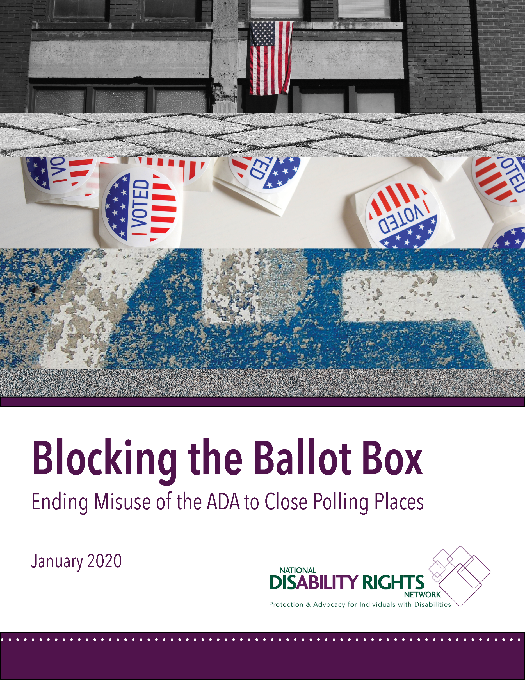

Blocking the Ballot Box
Ending Misuse of the ADA to Close Polling Places

TABLE OF CONTENTS
ACKNOWLEDGEMENTS 4
NDRN AND THE PROTECTION & ADVOCACY SYSTEMS 5
A LETTER FROM THE EXECUTIVE DIRECTOR 7
EXECUTIVE SUMMARY 9
VOICES FOR EQUAL ACCESS 12
METHODOLOGY 13
ACRONYM GLOSSARY 13
BACKGROUND: Polling Places, the ADA, and Something Amiss in Randolph County 15
SPOTLIGHT ON ACCESS: A Brief History of Water Fountains 17
FEDERAL LAW: Protecting People with Disabilities and Their Right to Vote 18
The Voting Rights Act of 1965 18
The Voting Accessibility for the Elderly and Handicapped Act of 1984 19
The Americans with Disabilities Act of 1990 20
ADA-Compliance at Polling Places 20
The National Voter Registration Act of 1993 24
The Help America Vote Act of 2002 24
POLLING PLACES: Widespread Accessibility Failures 26
Physical Access to Polling Places 26
Across the United States 26
South Carolina 27
District of Columbia 28
Arkansas 28
Four Corners Region 29
Texas 29
Vermont 30
Beyond Physical Access 30
Language Assistance: ASL and Plain Language 31
Distance 32
Absentee and Mail Voting Accessibility 33
POLLING PLACES: The Threat of Closure 34
Shelby County v. Holder 34
Polling Place Closures by the Numbers 35
Polling Place Closures and Relocations: Blamed on the ADA 36
Randolph County, Georgia 37
Toombs County, Habersham County, and Lumpkin County, Georgia 40
Pearl River County, Mississippi 40
McLennan County, Texas 41
Dauphin County, Pennsylvania 41
Baxter County, Arkansas 42
Jefferson Parish, Louisiana 42
Richland County, Ohio 43
Ford County, Kansas 43
Department of Justice: Enforcing the ADA 44
City of Chicago, Illinois 45
Jefferson County, Alabama 46
Richland County, South Carolina 48
Anderson County, South Carolina 49
Harris County, Texas 50
City of Chesapeake, Virginia 51
McKinley County, New Mexico 51
Coconino County, Arizona: A Closer Look 52
PRACTICAL SOLUTIONS: Making Polling Places Accessible & Avoiding Closures 63
Temporary Remedies to Polling Places 64
Parking 64
Ramps 65
Doors 65
Water Fountains and Protruding Objects 66
Relocating Polling Places 66
Consolidating Polling Places 67
“Accessible” Poll Workers 67
“Accessible” Money 68
CONCLUSION 69

ACKNOWLEDGEMENTS
The National Disability Rights Network (NDRN) wishes to thank the Ford Foundation and the Democracy Fund for their financial support of this project to explore the alarming trend of polling places closures blamed on people with disabilities and the Americans with Disabilities Act.
NDRN would also like to give a special thank you to JJ Rico and Renaldo Fowler of the Arizona Center for Disability Law and Therese Yanan of the Native American Disability Law Center for going above and beyond, traveling miles upon miles with NDRN staff to showcase what Native American voters with disabilities experience in the Four Corners region of the United States. Thank you to Coconino County’s Elections staff who spent the day with NDRN staff exploring the unique challenges their county experiences on Election Day.
NDRN also wants to express our deepest gratitude to community leaders of the Navajo Nation and Hopi Tribe who welcomed us with open arms in their community and shared the challenges they face while voting.
There would be no report without the time and input from elections administrators, voting rights experts, and disability rights advocates across the country, including:
- Adam Lasker, Association of Election Commission Officials of Illinois
- Alexander Castillo-Nunez, Inter Tribal Council of Arizona
- Barry Stephenson, Jefferson County, Alabama Government
- Barry Taylor, Equip for Equality
- Bebe Novich, Equip for Equality
- Berna Chavez, Disability Rights New Mexico
- Christian Adcock, Disability Rights Arkansas
- Disability Law Center of Alaska
- Gabe Labella, Disability Rights Pennsylvania
- Jim Tucker, Native American Rights Fund
- John Cusick, NAACP Legal Defense & Educational Fund, Inc.
- Julie Kegley, Georgia Advocacy Office
- Katy Smith, Anderson County, South Carolina Government
- Leah Aden, NAACP Legal Defense & Educational Fund, Inc.
- Leigh Chapman, Leadership Conference on Civil and Human Rights
- Maggie Knowles, Protection & Advocacy for People with Disabilities, Inc.
- Molly Broadway, Disability Rights Texas
- Nevada Disability Advocacy and Law Center
- Scott Simpson, Muslim Advocates
- Sharon Woodard, York County, South Carolina Government
- Shirley Walker-McKinnis, Disability Rights Mississippi
- Sophia Lin Lakin, American Civil Liberties Union
- Stephanie Patrick, Disability Rights Center – New Hampshire
- Stephanie West-Potter, Disability Rights Center of Kansas
- Tate Fall, Alabama Disabilities Advocacy Program
- Tom Masseau, Disability Rights Arkansas
- Torey Dolan, Sandra Day O’Connor College of Law
- Wanda Hemphill, York County, South Carolina Government
This report was researched and written by Erika Hudson and Michelle Bishop of the National Disability Rights Network. Curtis Decker, David Hutt, Eric Buehlmann, Tina Pinedo, Kenneth Shiotani and David Card edited the report.
Production was coordinated by Tina Pinedo and David Card.

NDRN AND THE PROTECTION & ADVOCACY SYSTEMS
The National Disability Rights Network (NDRN) is the nonprofit membership organization for the federally mandated Protection and Advocacy (P&A) Systems and the Client Assistance Programs (CAP) for individuals with disabilities. The P&As and CAPs were established by the United States Congress to protect the rights of people with disabilities and their families through legal support, advocacy, referral, and education. P&As and CAPs are in all 50 states, the District of Columbia, Puerto Rico, and the U.S. territories (American Samoa, Guam, Northern Mariana Islands, and the U.S. Virgin Islands), and there is a P&A and CAP affiliated with the American Indian Consortium which includes the Hopi, Navajo, and San Juan Southern Paiute Nations in the Four Corners region of the U.S.
As the national membership association for the P&A/CAP network, NDRN has aggressively sought federal support for advocacy on behalf of people with disabilities, and expanded P&A programs from a narrow initial focus on the institutional care provided to people with intellectual disabilities in facilities to include advocacy services for all people with disabilities no matter the type or nature of their disability and where they live. Collectively, the P&A and CAP Network is the largest provider of legally based advocacy services to people with disabilities in the United States.
Today P&As and CAPs work to improve the lives of people with disabilities by guarding against abuse; advocating for basic rights; and ensuring access and accountability in health care, education, employment, housing, transportation, voting, and within the juvenile and criminal justice systems. Through the Protection and Advocacy for Voter Access program, created by the Help America Vote Act, the P&As have a federal mandate to “ensure the full participation in the electoral process for individuals with disabilities, including registering to vote, casting a vote and accessing polling places” and are the leading experts on access to the vote for people with disabilities in the U.S.0F

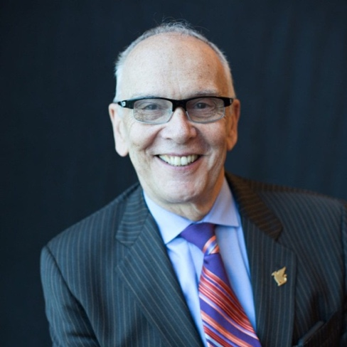
A LETTER FROM THE EXECUTIVE DIRECTOR
Dear Friends,
If you live in the United States, what are your rights? To this question, many of us might say the right to free speech, the right to petition government, the right to a free press, and the right to assemble. Or perhaps you would say the right to vote – the foundation of our democracy, the right on which all of these other rights depend.
As we have worked toward a more perfect union, the right to vote has evolved. The Fifteenth, Nineteenth, and Twenty-sixth Amendments to the United States Constitution have expanded the franchise, as legislation like the Voting Rights Act and the Help America Vote Act were passed to protect it. Today, although we have come so far over the course of our history, our electoral system remains far from perfect.
Voters across the country are still being denied equal access to the ballot box and this includes voters with disabilities. Laws, such as the Voting Accessibility for the Elderly and Handicapped Act and the Americans with Disabilities Act, are in place to protect the rights of people with disabilities and their access to the vote. Yet jurisdictions make routine decisions every election cycle, knowingly or unknowingly, that prevent equal access on Election Day. Americans have fought too long and too hard to create a representative government in which everyone has a voice and a vote. We must do better.
This means that we must stop blaming people with disabilities and the laws that protect their rights. Over the course of recent elections, we have heard of counties and cities closing, relocating, or consolidating their polling places while unjustly invoking the historic civil rights provisions of the Americans with Disabilities Act. Many of these same jurisdictions have lamented being “targeted” by the U.S. Department of Justice when it rightly steps in to enforce federal disability rights law and to ensure equal access at polling places across the country.
The narrative simply cannot be to blame people with disabilities for, in fact, being victims of widespread failure to comply with the Americans with Disabilities Act. Instead, we must come together with dignity and respect to ensure all eligible voters the same opportunity to a private and independent vote. This change will not be easy. People with disabilities know this all too well, as proven by years of unequal access and denial of their civil rights, but it must happen.
People with disabilities have overcome tremendous odds to participate in elections, but they simply should not have to. People with disabilities will continue to have their voices heard on Election Day. They are a force in American politics. They cannot and will not be scared off from the ballot box as the U.S. strives for full realization of equal access.
Sincerely,
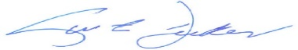
Curtis L. Decker, J.D.
Executive Director

EXECUTIVE SUMMARY
We don’t make polling places accessible by closing them. We make them accessible by making them accessible.
– Michelle Bishop, Disability Voting Rights Specialist, National Disability Rights Network
America’s electoral system is complex, extremely localized, and operates in an environment of unrealistic expectations of perfection. Although voting laws in the United States have changed over time and advanced access for all voters, the nation still has a long way to go in order to ensure that all Americans have equal access to the vote. Throughout history, Black voters, low-income voters, women voters, Native American voters have not always had their right to vote protected, and even now well into the 21st century. America still struggles to ensure equal access to the ballot box.
People with disabilities crosscut every American demographic, and voters with disabilities are a part of every voting bloc in society. Yet, voters with disabilities have also been restricted from the vote throughout history, which continues today. People with disabilities face significant barriers when participating in U.S. elections, preventing equal access to the vote. Despite the fact that the Americans with Disabilities Act (ADA) of 1990 requires all polling places to be accessible to people with disabilities and the Help America Vote Act (HAVA) of 2002 mandates that all Americans have the right to a private and independent vote, polling places and voting stations across the U.S. remain largely inaccessible.
National and state-based surveys have shown time and time again that America’s polling places have long been inaccessible to voters with disabilities. The United States Government Accountability Office (GAO) in 2016 found that 40 percent of U.S. polling places were accessible during that year’s November election. With 40 percent representing an all-time high for polling place accessibility, less than half of America’s polling places were accessible during a presidential election. The GAO, as well as surveys conducted in states like South Carolina, Arkansas, Texas, and Vermont, have found these barriers include unpaved parking, unsafe sidewalks, and inaccessible entrances, hallways, and voting areas. Despite the fact that people with disabilities face barriers to the ballot box, they are alarmingly also being blamed for preventing others from voting as well.
When the United States Supreme Court struck down key provisions of the Voting Rights Act (VRA) of 1965 in Shelby County v Holder in 2013, it allowed jurisdictions with a demonstrated history of discriminatory voting practices to change freely how their elections are administered without the voter protections offered by federal preclearance. Voters across the country were, and still are, negatively impacted by new barriers created after the Shelby County decision. Following the enactment of strict voter identification laws, voter purges, and polling place closures, not all voices are being heard on Election Day, and worse, they are being deliberately silenced.
Local jurisdictions in various states have gotten away with blaming their polling places closures on the access needs of voters with disabilities. The closures effectively suppress the vote in those jurisdictions and create a national environment of fear among voting rights activists. A false narrative that the federal government is encouraging jurisdictions to close polling places if they are not accessible under the law leaves disability rights activists hard-pressed to advocate for poll access.
The United States Department of Justice (DOJ) has been tasked with enforcing the ADA since its passage, and as a result, have intervened in many jurisdictions that are out of compliance with the ADA. DOJ intervention typically results in a settlement agreement that mandates ADA- compliance through any number of measures, including temporary accessibility modifications or measured relocation of polling places to more accessible locations. The DOJ also cautions jurisdictions against closing polling places in their enforcement of the ADA. Overwhelmingly, jurisdictions that experienced DOJ intervention followed the Department’s recommendations to make their polling places more accessible in cost-effective ways, while preventing unnecessary poll closures. Meanwhile, jurisdictions that attempted to close a significant percentage of their polling places and cited the ADA typically were not under a settlement agreement with the DOJ. These jurisdictions failed to provide ADA accessibility surveys or any evidence of coordination with disability advocacy organizations to resolve access barriers.
Jurisdictions like the City of Chicago, Illinois and Coconino County, Arizona have made headlines for their recent DOJ settlement agreements and for their efforts to comply with the ADA. Chicago, a diverse area with a large number of polling places; and Coconino County, the second largest county by area in the nation consisting largely of Native American Sovereign Nations, have made their best efforts to ensure voters have equal access to polling places. The settlement agreements with these jurisdictions, however, have been called into question by voting rights activists and the media even while doing their best to ensure that all voters have equal access to polling places in their home communities.
The disability community does not encourage polling place closures. Rather, disability rights activists encourage communities to work together to provide permanent or temporary fixes to polling places. Disability rights organizations at the state and national level spoke out against the aborted plan to close polling places in Randolph County. Disability rights activists recognize that poll closures hinder access for all voters, including those with disabilities. The solution to inaccessible polling places is not to close them…it is to make them accessible. Further, the cost of making polling places accessible can perhaps be much cheaper than arguing against it in court.
Many creative solutions already exist to ensure access. Many polling places can be permanently or temporarily modified at little to no cost. Reasonably accessible locations may only require changing the path of travel or utilizing a more accessible area in the same location. In some cases, polling places may need to be relocated or consolidated with another polling place in the immediate area in order to achieve access. Finding the best solution, and keeping polling places open, relies on including people with disabilities in the planning process, combining elections official’s expertise in administering elections with disability advocate’s expertise in providing access.
It is evident that none of this happened in Randolph County and in many other areas across the country, resulting in attempted localized voter suppression, as well as national confusion and finger pointing. Jurisdictions under DOJ intervention are often eager to do the right thing and comply with federal accessibility law. To do so, election officials must increase their capacity by tapping into the local disability community and their expertise in the access needs of voters with disabilities. Conversely, jurisdictions leveraging disability rights law to close large numbers of polling places with little to no evidence of the closures’ necessity must be prevented from suppressing voter participation. Federal preclearance under the VRA has proved an effective vehicle for deterring these kinds of discriminatory practices and must be fully restored. Other recommendations and suggestions are available in the conclusion section of this report.

VOICES FOR EQUAL ACCESS
“We tell the person with a disability to park outside the 75-foot limit, and when they park outside, they have about 50 – 60 yards to the ramp way to get into the building. Still it’s not accommodating to them.”

– Angelina James,
Advocate
Second Mesa, Arizona
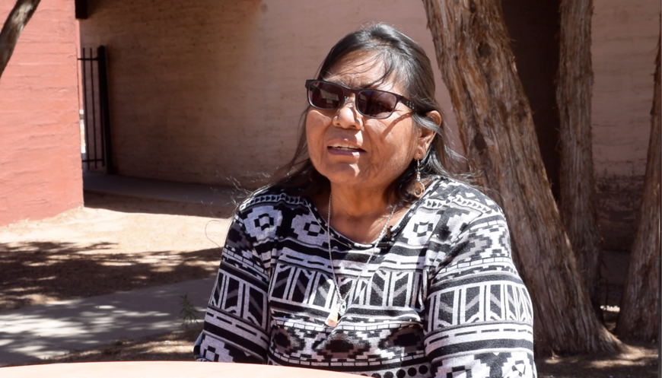

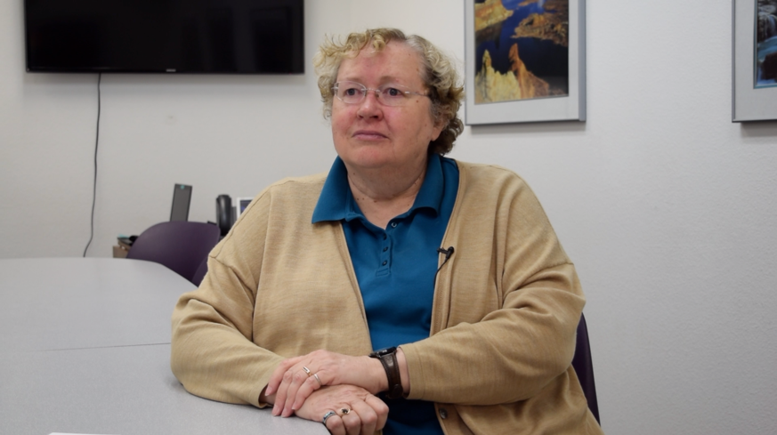
“We’ve entered into agreement with the Department of Justice to try and make our polling places as accessible as possible.”

– Patty Hansen,
Recorder
Coconino County, Arizona

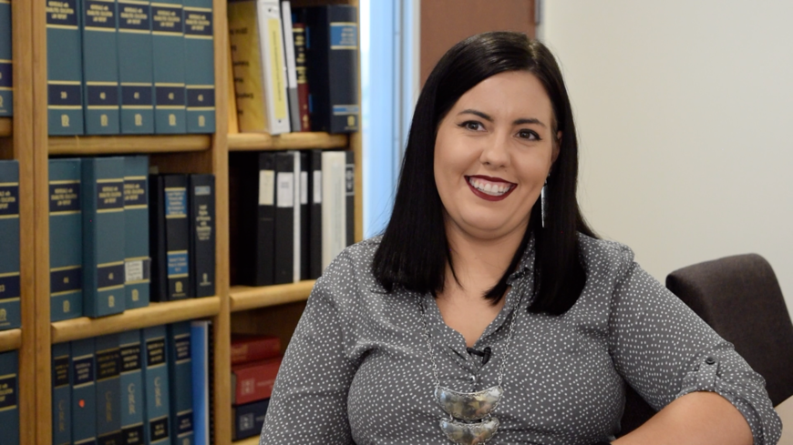
“…Counties and tribes should be working together to make these sites accessible. The goal of all these governments is to serve the same people.

– Torey Dolan, Indian Legal Clinic Native Vote Fellow at the Sandra Day O’Connor College of Law, Arizona State University

METHODOLOGY
This research analyzes whether jurisdictions are using the ADA as a pretext to close polling places across the country and the role of the U.S. DOJ, which is tasked with enforcing the ADA. The analysis relied on polling place accessibility surveys completed and aggregated by Protection and Advocacy (P&A) systems, U.S. Government Accountability Office surveys of polling place accessibility across the country dating to 2000, data on polling place usage from the U.S. Election Assistance Commission (EAC)’s Election Administration and Voting Survey (EAVS), and the Leadership Conference on Civil and Human Right’s Democracy Diverted: Polling Place Closures and the Right to Vote report, and public settlement agreements on ADA-compliance of polling places with the DOJ under the Department’s ADA Voting Initiative and Project Civic Access Initiative.
Interviews were also conducted with P&A staff and local election officials in reviewed jurisdictions to collect qualitative data on the barriers faced by voters and election administrators on Election Day and beyond. NDRN staff traveled to Coconino County, Arizona in September 2019 to interview elections staff, community and tribal leaders and to examine several polling places first-hand, including Cameron’s Senior Center, Tuba City High School, Moenkopi Community Center, and Coalmine Chapter House.

ACRONYM GLOSSARY
VRA Voting Rights Act of 1965
VAEHA Voting Accessibility for the Elderly and Handicapped Act of 1984
ADA Americans with Disabilities Act of 1990
NVRA National Voter Registration Act of 1993
HAVA Help America Vote Act of 2002
ADAAG ADA Accessibility Guidelines
P&A Protection and Advocacy
CAP Client Assistance Program
PAVA Protection and Advocacy for Voter Access
DOJ Department of Justice
FY Fiscal Year
GAO Government Accounting Office
EAC Election Assistance Commission
DRDC Disability Rights DC
DRTx Disability Rights Texas
DRA Disability Rights Arkansas
DRVT Disability Rights Vermont
ASL American Sign Language

BACKGROUND: POLLING PLACES, THE ADA, AND SOMETHING AMISS IN RANDOLPH COUNTY
In August 2018, Randolph County, a majority black county in rural Georgia, made national news for proposing to close seven out of its nine polling places ahead of a highly contested November gubernatorial election. The reason given – a landmark civil rights law, the ADA.
Signed in 1990, the ADA is the major civil rights law in the United States that protects the rights of people with disabilities. The ADA outlawed disability-based discrimination, in employment and public programs, and granted equal access to public goods and services for people with disabilities. Specifically, Title II of the Act mandates that people with disabilities must be given full and equal opportunity to vote by federal, state, and local governments. In other words, the ADA requires counties and cities in the U.S. to select and use polling places that are physically accessible to everyone, including “people with a variety of disabilities, such as those who use wheelchairs, scooters or other devices; those who have difficulty walking or using stairs; or those who are blind or have vision loss.”1F
The U.S. Census Bureau reported in 2010 that 56.7 million people with disabilities live in the United States, totaling approximately 19 percent of the U.S. non-institutionalized population.2F The Centers for Disease Control and Prevention3F and Pew Research Center4F believe that number is now closer to 25 percent, or one in four Americans. Further, the School of Management and Labor Relations at Rutgers University projected that there were 35.4 million people with disabilities eligible to vote in the U.S., one-sixth of the total American electorate, during the 2016 Election.5F
The size of the disability community and the magnitude of the ADA and its positive impact on civil rights and American life simply cannot be overstated. The ADA is the standard in enforcing access to the ballot for eligible voters with disabilities, protecting their voice in democracy.
A number of counties that have attempted to shutter a high percentage of polling places in the last several election cycles cite failure to follow Title II of the ADA, which may be true. In fact, given the Government Accountability Office’s data on the pervasive nationwide failure to comply with the ADA in elections administration – it is very likely true. However, the ADA does not mandate closure of inaccessible polling places in its provisions. In fact, DOJ explicitly cautions against closing polling places in their enforcement of the ADA. Similarly, disability advocates in the U.S. do not suggest closing polling places to resolve ADA violations.
Unfortunately, what happened in Randolph County was not an isolated incident. Multiple jurisdictions have flown largely under the radar in citing the ADA as the reason for closing, relocating, and consolidating their polling places. Some jurisdictions say they have no choice but to close or relocate. Anecdotally, some jurisdictions do not think they are doing anything wrong alleging that no people with disabilities live in their community and therefore they do not need to follow the ADA. Still, some jurisdictions do not even know they are violating the law, claiming confusion over the ADA’s provision and its interaction with state laws. For elections officials with limited in-house capacity, the ADA is often seen as a burden to those who do not benefit from its protections every day. The work of disability rights advocates and federal enforcement are necessary to combat persistent ignorance and confusion surrounding the ADA and ensure equal access for every American.

SPOTLIGHT ON ACCESS: A BRIEF HISTORY OF WATER FOUNTAINS
Most water fountains today, or “bubblers” as some like to say, look standard. They are mounted on walls at about waist level and most people have to bend down to take a sip of water, or perhaps lift children up so they can take a sip on a nice hot summer day. Some drinking fountains even have those updated reusable bottle refill stations for easy access. That is to say, water fountains have evolved over the years. In the past, water fountains were connected to the ground, instead of mounted on the wall. The “floating” redesign seen today is actually what makes them accessible to wheelchair users, who are then able to roll underneath to reach the spout. Yet, the same drinking fountains that once were not accessible to wheelchair users have created a new kind of barrier, they cannot always be detected by a white cane sweeping across the ground so that people who are blind or visually impaired can navigate around them.
The solution was to take something that should have been accessible to everyone all along and re-envision it to be so.
Veritably, the solution that provided access for one person with a disability created a dangerous accessibility barrier for another. The disability community is large and diverse, and each type of disability differs from the next and invites a unique set of access barriers to be toppled. Yet with a little innovation and commitment to good design, the same bubbler can be made accessible for all. Water fountains ideally are mounted on the wall with open clearance underneath to accommodate wheelchairs, but placed within a small alcove carved out of the wall so that the fountain is no longer blocking a path of travel and does not need to be cane detectable. The solution was not to close the water fountain and force all thirsty citizens to travel great distances to the next available bubbler. The solution was not to allow non-disabled drinkers to access the fountain, while expecting people with disabilities to drink at home or wait for a pitcher to be brought outside.
This is not to say that water fountains are at the core of the problems facing today’s voters. However, much like the trusty water fountain, electoral systems have been re-designed continually to promote access to the vote for all…and somehow have managed to largely leave many voters with disabilities behind.
The solution was to take something that should have been accessible to everyone all along and re-envision it to be so.

FEDERAL LAW: PROTECTING PEOPLE WITH DISABILITIES AND THEIR RIGHT TO VOTE
For decades during American history, literacy tests, poll taxes, and other voter suppression tactics have restricted and prohibited the right to vote. More recently, polling place closures, strict photo identification laws, and purging of voter rolls have emerged as threats to the core of our democracy and have prevented voters from participating in their electoral system. Yet, Constitutional amendments and passage of sweeping voting rights laws have continually combatted barriers to the ballot box as they arise. People with disabilities have been impacted by every Constitutional amendment and piece of legislation related to voting, as disability lies within every community.

The Voting Rights Act of 1965
The Voting Rights Act (VRA) of 1965 prohibits known discriminatory practices, including literacy tests, and established federal preclearance as a proactive measure to prevent voter suppression. A historic achievement for the civil rights movement, the VRA is also likely the oldest legislation of its kind to include provisions for people with disabilities. Section 208 of the VRA provides that “any voter who requires assistance to vote by reason of blindness, disability, or inability to read or write may be given assistance by a person of the voter’s choice, other than the voter’s employer or agent of that employer or officer or agent of the voter’s union.”6F
Section 5 of the VRA mandates that counties and cities with a history of discrimination report any changes in election administration to the DOJ and the U.S. District Court for the District of Columbia prior to making any changes, including closing or relocating polling places. Section 4 of the VRA includes a formula to determine which states or jurisdictions will be subject to federal preclearance. To many, federal preclearance under the VRA was an invaluable tool to ensure discrimination was stopped before it began.

The Voting Accessibility for the Elderly and Handicapped Act of 1984
Prior to 1984, polling places were not required to be physically accessible for people with disabilities or required to accommodate people with disabilities, even if it meant they could not vote because of it. However, when Congress passed the Voting Accessibility for the Elderly and Handicapped Act (VAEHA) in 1984, states were required to ensure accessible polling places during federal elections. The VAEHA sought to give people with disabilities the right to equal access to polling places six years before the passage of the Americans with Disabilities Act.7F

The Americans with Disabilities Act of 1990
Although some improvements to polling place access were required by prior voting rights legislation, the ADA was the landmark civil rights legislation for people with disabilities, which includes provisions for voting.8F While the VAEHA allowed for alternative means to vote when those with disabilities were assigned to an inaccessible polling place, Title II of the ADA requires state and local governments to ensure that people with disabilities have a full and equal opportunity to vote. The ADA was the first piece of major legislation to require the equal treatment of people with disabilities by society. As George H.W. Bush famously stated when signing the ADA in 1990, “Let the shameful wall of exclusion finally come tumbling down.''9F

ADA-Compliance at Polling Places
According to the DOJ, the five most common ADA violations at polling places over recent years include: 1.) Parking 2.) Sidewalks 3.) Entrances 4.) Hallways and 5.) The voting area itself.10F Understandably, these violations can be somewhat complicated. For example, simply paving a sloped parking lot or building a ramp that is too steep or not wide enough will not provide access. Public and private entities need to consider all elements of accessibility, including slopes, grades, and distances to make curb cuts, sidewalks, parking lots, passenger drop off areas, and other paths of travel usable and safe. In other words, the most well intended paved parking lots, ramps, or other accessibility changes can still be inaccessible if not in compliance with the ADA Accessibility Guidelines (ADAAG).11F

PARKING
In order to ensure ADA-compliance of parking lots, election officials must refer to precise measurements and collect accurate data. The ADA provides requirements for access aisles - those areas where cars do not park and that allow enough space for an accessible vehicle’s ramp or lift to deploy for wheelchair access. Under the ADA, access aisles must be at least 60 inches wide for cars and 96 inches wide for vans. Access aisles typically feature diagonally striped lines or some way to indicate “no parking.” In addition, while a jurisdiction looking to affordably bring an unpaved parking lot into compliance may opt to pave only the accessible parking space, the parking space and access aisle itself must not have a significant slope and must be level with the rest of the parking area to prevent a wheelchair from falling backwards off the paved accessible space.
All accessible parking spaces must include signs to ensure full ADA-compliance. A sign designating the accessible space for people with disabilities must be placed by every individual accessible parking space so that every driver knows the space can only be used by those with accessible parking license plates or tags, as determined by the state.
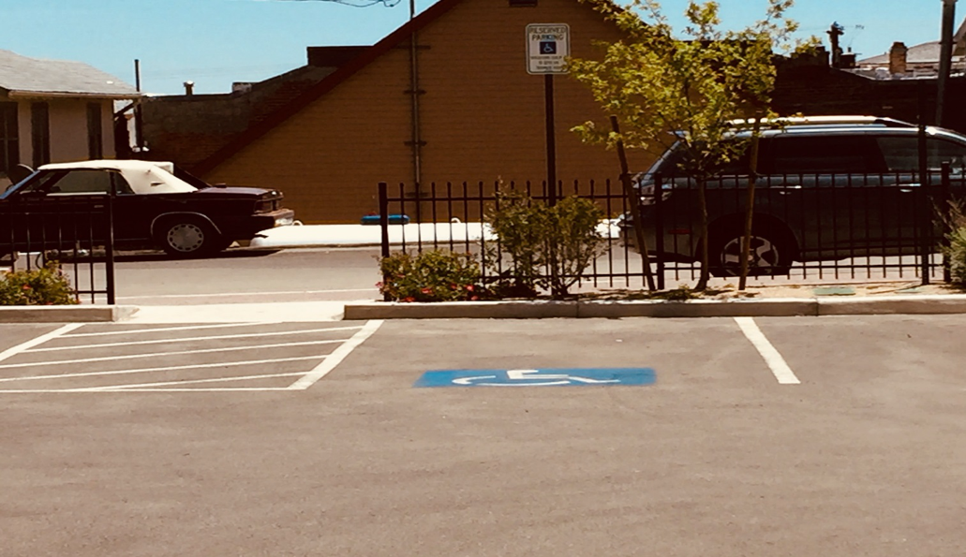
An accessible parking spot at a polling site in Virginia City, located in Storey County, Nevada. Photo courtesy of Nevada Disability Advocacy and Law Center.

SIDEWALKS
Safe sidewalks are crucial for voters with disabilities to have equal access to their polling places. Sidewalks must be at least 36 inches wide and must not have level changes greater than half an inch. They also need to be maintained and repaired when needed. Good sidewalks make things easier for everyone. Not only do those who use wheelchairs, walkers, and canes greatly benefit from safe sidewalks, but those with strollers, or people with temporary disabilities (such as a cast and crutches for a broken leg) use them as well. It is required that curb ramps (curb cuts), the ramps that enable access on and off of sidewalks, not be too steep. Curb ramps are dangerous if they are too steep or lack flared sides and could in fact force a person with a disability into oncoming traffic if the ramp cannot be traversed successfully.
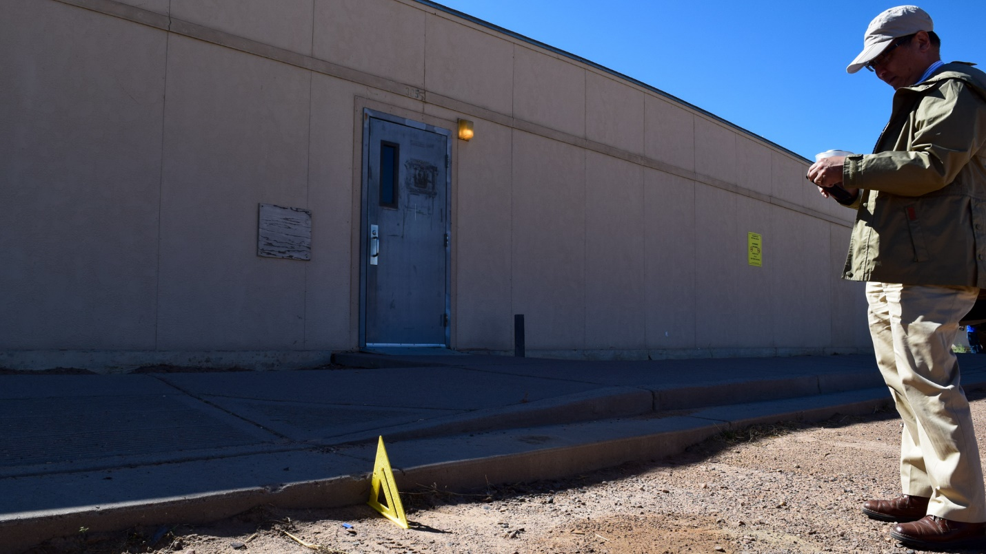
Kenneth Shiotani, NDRN Senior Staff Attorney, measures the height of a curb drop off.

ENTRANCES
Polling place entrances must be ADA accessible as well to ensure equal access. No voter’s ability to access the ballot should depend on the kindness of strangers to hold a door open for a voter with a disability. All door openings must provide at least 32 inches clear width, and the door threshold should not exceed a half an inch in height and be beveled if more than one-quarter inch in height. As with parking and sidewalks, entrance areas must be level and should not slope steeply in any one direction. For example, a wheelchair user must be able to open the door with enough space to back up or maneuver and provide space for the door’s swing without being hit by the door, blocked from the doors opening, or rolling backwards. Additionally, the door handle itself must not require tight grasping, pinching, or twisting – such as a round knob. Rather, lever type door handles, which are operable with a closed fist, provide access to most people.

HALLWAYS
Hallways at polling places must provide an accessible route of at least 36 inches clear width. Hallways should not have any objects protruding the path of travel to the voting area itself at a polling place in order to accommodate different types of mobility devices, like wheelchairs. For example, wall-mounted objects such as water fountains should be mounted inside an alcove in the wall that prevents any protrusion. Otherwise, water fountains or other objects cannot extend more than 4 inches from the wall and cannot reduce the clear route and also should be detectable by a white cane used by those who are blind to navigate a path.

VOTING AREA
The voting area itself (i.e. start to finish path of travel from entering the area, to voting stations, to exiting the polling place) must provide an accessible route that is at least 36 inches wide. The floor surfaces in the voting area must also be flat and stable. Power cords for accessible voting and other devices must be covered or taped down to prevent tripping.

The National Voter Registration Act of 1993
The National Voter Registration Act (NVRA or Motor Voter Act) of 1993 made it easier for Americans to register to vote, including people with disabilities. For example, the Act requires states to offer voter registration opportunities at offices that provide public assistance and services to people with disabilities, such as Vocational Rehabilitation services and Independent Living Services.12F

The Help America Vote Act of 2002
In 2002, Congress passed the Help America Vote Act (HAVA) with the goal to reform the voting process throughout the country and make it easier for all Americans to participate in democracy. HAVA mandates that voters with disabilities have the same opportunity to vote “privately and independently” by requiring that every polling place have at least one voting system that is accessible to people with disabilities.13F Accessible voting systems are typically either a direct recording electronic (DRE) voting system, which uses an electronic interface to cast and record votes electronically with or without a paper back up, or ballot marking devices (BMDs), that use an electronic interface to assist voters to mark selections on a paper ballot that is then cast.14F
HAVA also established the U.S. Election Assistance Commission (EAC) as an independent, bipartisan federal commission to develop guidance and act as a clearinghouse of best practices to meet HAVA’s requirements, including access for voters with disabilities. Additionally, HAVA created the PAVA program as a direct charge to P&As to assist in HAVA’s implementation and ensure voter access for people with disabilities from registration to casting a ballot. PAVA is the first dedicated source of funding for advocacy for voters with disabilities.

POLLING PLACES: WIDESPREAD ACCESSIBILITY FAILURES
Despite laws to protect people with disabilities’ right to vote by mandating public entities, such as polling places, be accessible — jurisdictions consistently fall short on delivering equal access to people with disabilities.

Physical Access to Polling Places
Polling place closure is not appropriate, but it is important to acknowledge that many polling places are still not accessible to people with disabilities, despite over 30 years of the VAEHA and ADA. The U.S. Government Accountability Office (GAO)15F and the P&A Systems, the nation’s largest providers of legal advocacy services for people with disabilities, have published numerous reports over the years highlighting the many barriers that still face people with disabilities while voting.

Across the United States
The GAO has issued congressionally requested reports dating back to 2000, immediately before the enactment of HAVA, creating arguably the most comprehensive record of the lack of ADA-compliance in America’s polling places. GAO’s most recent report following the 2016 presidential election surveyed 178 polling places across the country, of which 107 of those polling places posed barriers to voters with disabilities.16F
According to the GAO’s report, 28 of the 178 polling places had ADA violations related to parking. Fifty-eight polling places had issues related to the path of travel up to the entrance of the polling place, and 39 polling places alone had inaccessible building entrances. Thirty-five of the polling places had barriers related to the path of travel to the voting area, while inside the polling place. Furthermore, of the 178 polling places, the GAO was able to examine 137 voting stations and found that 89 of them violated HAVA and the ADA by not providing an accessible voting system that was ready for use and allowed for a private and independent vote.17F

South Carolina
In October 2018, Protection and Advocacy for People with Disabilities Inc., South Carolina’s P&A, issued a report on polling place accessibility. They surveyed a total of 32 polling places and found that all 32 of the polling places they surveyed violated either VAEHA, the ADA, and/or HAVA.18F P&A staff and volunteers discovered inaccessible parking, walkways, and entrances, as well as inaccessible voting machines and a lack of ramps.
The P&A issued key recommendations to prevent inaccessible polling places in future elections. Their main recommendation was training; election officials must understand the various disability rights laws and how to implement them properly. Many of the problems discovered by the P&A could be eliminated with proper training to election officials and poll workers, not requiring closures of the polling places.19F

District of Columbia
During the June 2018 primary election, Disability Rights DC (DRDC), the District of Colombia’s P&A, surveyed 121 polling places in the District. DRDC reported that 14 percent of the polling places they surveyed were structurally inaccessible while 34 percent of the polling places were operationally inaccessible. In the report, structurally inaccessible refers to obstructed paths to voting areas, lack of accessible entrances, and inaccessible ramps and elevators. Operationally inaccessible meant lack of signage, closed doors, malfunctioning doorbells, and lack of available poll workers.20F

Arkansas
From October 2017 to July 2018, Disability Rights Arkansas (DRA), Arkansas’s P&A, surveyed polling places in each of the state’s counties. DRA was able to survey 90 percent of the state’s polling places and found that 49 percent of them were inaccessible to people with disabilities.21F Their survey findings noted that parking was the most common violation, with 866 out of the total 1,110 polling places having accessibility violations in parking.22F
DRA also noted in their report that 490 of the state’s polling places at the time were owned by churches or religious organizations. Churches and religious institutions are one of the few places where people gather that are not covered by the ADA. However, all polling places are subject to ADA regulations, whether or not they are being housed at a facility with a religious affiliation. Thus, the onus is placed on the jurisdiction’s election officials to ensure that the polling place is at least temporarily accessible under the ADA when the facility is being used as a polling site.23F

Four Corners Region
The Native American Disability Law Center, the American Indian Consortium’s P&A, is located in the four corners region of the U.S. — covering parts of Colorado, Utah, Arizona, and New Mexico. In 2013, the Law Center issued a report entitled The Fundamental Principal of a Participatory Democracy: Equal Access for Navajos with Disabilities.24F The Law Center staff and volunteers surveyed 25 polling sites in five major communities across the Navajo Nation that host tribal, state, county, and federal elections and found that every single polling place they surveyed had barriers to people with disabilities. These barriers included unpaved parking lots, inaccessible door handles, and limited accessible signage.25F

Texas
Disability Rights Texas (DRTx), the Texas P&A, conducts regular polling place accessibility checks and offers their services free of charge to county election officials to ensure that their polling places are ADA-compliant before Election Day. On June 25, 2019, DRTx surveyed four polling sites in Callahan County, Texas. The P&A found that all four of Callahan County’s polling places had problems with parking, including a lack of accessible parking spaces for lift or ramp equipped vans, inaccessible door handles, and steep slopes.26F
One of the polling places DRTx examined had a ramp that measured a slope of around 10 percent. The maximum running slope allowed for ramps is no steeper than 8.33 percent (1:12 ratio). DRTx recommended the County correct the slope in order to meet the ADA requirements or the polling site should be relocated to an accessible location. Acknowledging that the recommendation might seem drastic, DRTx’s HAVA Training & Technical Support Specialist Molly Broadway, LMSW said, “If you aren’t someone who relies on the protections of the ADA for your everyday functioning, I think it’s really easy to say that you’re being persecuted based on this law.”27F Yet, the ADA’s very specific regulations exist for good reason. A ramp with a slope that is too steep can be impossible for a manual wheelchair user to ascend and could be dangerous to descend.

Vermont
In July 2018 Disability Rights Vermont (DRVT), Vermont’s P&A, issued their polling place accessibility report outlining the challenges voters with disabilities experience on Election Day in their state. DRVT found that every county surveyed had polling places that were not ADA-compliant. Compliance problems included a lack of van-accessible parking, inaccessible entrances, and no accessible ramps on election days.28F

Beyond Physical Access
Although it is one of the most widely cited reasons why people with disabilities are denied access to America’s electoral system, physical accessibility at polling places is far from the only barrier facing voters with disabilities today. Other barriers include language assistance, lack of knowledge from poll workers (about the right to assistance in casting a vote and how to use accessible voting equipment), and distance to polling places, especially where there are limited public transportation options.

Language Assistance: ASL and Plain Language
Congress expanded the VRA in 1975 and established what is known as the “language minority provision.”29F The language minority provision requires jurisdictions to provide voting materials in English and the language of the applicable minority group in a given area, such as registration or voting notices, forms, instructions, and assistance or information relating to the electoral process and ballots.30F However, when discussing minority languages, election officials and poll workers must remember that American Sign Language (ASL) is a minority language.
The Department of Justice’s ADA guidelines state that “to ensure that voters with disabilities can fully participate in the election process, officials must provide appropriate auxiliary aids and services at each stage of the process, from registering to vote to casting a ballot” and “officials must give primary consideration to the request of the voter.”31F This includes visual instructions at polling places or a poll worker who speaks ASL. However, people must request auxiliary aids and services in advance by contacting their state election officials.32F
A voter who does not speak the same language as a poll worker or fully understand the written material both frustrates the voter and can prevent them from receiving legally required auxiliary aids, services, or other accommodations on Election Day. Jurisdictions need to provide materials in plain language which are written clearly, in a logical order, and in an active voice. Plain language voting materials should define terms and abbreviations, and be made available to all poll workers and voters, including those with disabilities.33F
Jurisdictions must strive for equal access at the polls and to the polls.

Distance
Jurisdictions need to consider the distance required for voters to get to the polls when selecting polling places. Although voters whose polling place is nestled in their home neighborhoods may find it hard to imagine, some voters need to travel over 90 miles to get to their polling place on Election Day.34F It is also important to consider the distance between the polling place and the nearest public transportation stop as some people rely on public transportation to get to the polls, including any voter whose disability prevents driving. While mail-in voting is rising in popularity and commonly offered as a solution to remote or inaccessible polling places, traditional mail voting is also inaccessible for many voters with disabilities, and voters have a legal right to equal access. Unless all voters are expected to mail in a ballot, election officials cannot require one subset of voters to do so. Rather, jurisdictions must strive for equal access at the polls and to the polls.

Absentee and Mail Voting Accessibility
Over the past few election cycles, absentee voting has increased in popularity, and in fact, it is the fastest-growing method of voting in America.35F However, it is not fully accessible. For instance, voters that are blind or low vision, have limited manual dexterity, and other people with disabilities cannot see or physically mark paper ballots independently and privately like other voters who choose to vote by mail.36F The rise of electronic delivery of blank ballots creates opportunities to complete the ballot privately and independently, using personal assistive technology. Yet if voters are expected to print out and return a paper ballot, the process remains inaccessible. While the introduction of electronic transmission has made absentee and mail voting more accessible, it is not a full solution and relies on the voters having access to their own personal technological devices, as well as reliable internet or cellular data service.

POLLING PLACES: THE THREAT OF CLOSURE
Close examination of polling place closures reveals an alarming trend – the ability of states and local jurisdictions to close polling places at their leisure. For years, the federal preclearance provision of the VRA was the law of the land in states like Georgia, Arizona, Mississippi, and jurisdictions in Michigan, New York, North Carolina, and others. However, in 2013 the U.S. Supreme Court changed the course of history with a 5-4 ruling in Shelby County v. Holder by striking down the formula used to require preclearance as set forth in the VRA in any state or jurisdiction with a demonstrated history of discriminatory practices.37F

Shelby County v. Holder
On June 25, 2013, the Supreme Court ruled that the “coverage formula” in Section 4(b) of the VRA was unconstitutional. The Supreme Court did not rule on the constitutionality of Section 5 itself, leaving a federal preclearance program intact. Yet, the coverage formula determined which jurisdictions were subject to preclearance under Section 5 of the law. When the Court struck down the primary avenue to determine which states required preclearance, it immediately freed jurisdictions with known discriminatory practices. Today, such jurisdictions no longer need to seek approval before enacting voting changes — including the closure, relocation, and consolidation of their polling places. As a result, the U.S. has seen a dramatic drop in the numbers of polling places across the country over the last few years.38F

Polling Place Closures by the Numbers
In September 2019, the Leadership Conference on Civil and Human Rights reported that 1,688 polling places had closed in jurisdictions that were previously under the preclearance requirement of the VRA between 2012 and 2018.39F
The U.S. EAC reported that election officials operated 116,990 polling places during the 2016 Election while they operated 119,968 polling places in 2012. The EAC credited this decrease to the expansion of alternative voting options such as absentee, early, and mail voting, as well as transition from traditional polling places to vote centers (a high-capacity polling place where any voter in the entire jurisdiction can choose to vote on Election Day).40F
However, the EAC did report in the 2018 Midterm Election that 230,871 polling places were used, an increase from both 2012 and 2016.41F Yet, these figures do not highlight which jurisdictions closed their polling places, and those that increased the number of polling places in use. Essentially, the numbers do not always paint a full portrait of polling place closures in the U.S.42F To illustrate, while some jurisdictions may report a drastic drop in the number of polling places, raw data may not show that the state implemented mail-in balloting for all voters supplemented with a more limited number of voter centers. Additionally, these figures also do not describe the jurisdictions that relocated their polling places, potentially to the detriment of voter access. It is also important to note that jurisdictions self-report their information to the EAC, and the questions jurisdictions are asked to respond to have changed over the years. Qualitative data that tells the stories of these jurisdictions are the best way to truly understand where polling place closures are happening and why.

Polling Place Closures and Relocations: Blamed on the ADA
Alarmingly, recent polling place closures, consolidations, and relocations across the country are being unjustly blamed on the ADA. To be clear, the ADA should never be used as the impetus to close large numbers of polling places. Occasional consolidations or reasonable relocations may be necessary to bring a polling place that always should have been accessible to all into compliance with the ADA. For example, a polling place with a parking area and path of travel located on a steep hillside cannot be temporarily modified or reasonably afford to have the entire grounds leveled. In which case, the polling place may have to be moved to a more accessible location in the immediate vicinity. But ultimately, the way to make polling places accessible is not to close them; it is to make them accessible. The ADA is a civil rights law which mandates equality for all at the polls, and yet shockingly, it has been used in recent years to pit civil and voting rights allies against each other in the struggle for access to the ballot. Jurisdictions and election officials claim that because of the costs associated with making their polling places ADA-compliant, they are better off relocating the polling places, or worse, closing them altogether.
Low-cost, permanent or temporary fixes can be made to existing polling places to prevent relocation, consolidation, or closure.
Title II of the ADA mandates that state and local governments do not deny participation in or the benefits of services, programs, or activities of state and local governments to any American, which includes voting in elections. Prior to the ADA, the VAEHA required that polling places also be accessible to people with disabilities dating all the way back to 1984. Essentially, mandating accessible polling places and equal access for voters has been required by law for 35 years. Clearly, given the abysmal rate of ADA-compliance among polling places, jurisdictions across the U.S. continue to act as if they do not need to follow the law.
Jurisdictions that raise their consciousness of ADA regulations and bring their electoral systems into compliance should be recognized for their efforts. Regardless, when a jurisdiction realizes they are not compliant with the law, it does not mean the “best” solution is to close a significant percentage of polling places. In most cases, low-cost permanent or temporary fixes can be made to existing polling places to prevent relocation, consolidation, or closure.

Randolph County, Georgia
The fact that the ADA can be weaponized to close polling places struck a national nerve in August 2018, when a rural county in southern Georgia announced plans to close seven out of only nine polling places in a majority Black community just three months before Election Day. The news of this announcement made national headlines including CNN43F, Fox News,44F and the Washington Post.45F
In 2018, Randolph County had a population of about 7,224 people across 428 square miles.46F In August of that year, the county’s two-member Board of Elections hired a consultant to review the county’s polling places in the hope of saving money. As a result, the election consultant recommended closing all but two polling places, claiming that the seven in question were not ADA-compliant.
The election consultant, Mike Malone, said regarding Randolph County, “The trend in Georgia, and other states, is to reduce the polling places, to reduce election costs, which is natural.”47F Yet, this reasoning stands in direct contradiction to earlier claims of ADA-compliance. Malone failed to produce DOJ-issued ADA surveys of the polling places or any evidence of coordination with disability access experts in making these claims. Options for adapting inaccessible polling places were not considered publicly.
It is also important to acknowledge that in 2018, the state of Georgia was undergoing a heated, historic gubernatorial election with the state’s first-ever female African American candidate to run for governor, Stacy Abrams. Her opponent, Brian Kemp, was Georgia’s Secretary of State at the time — the state's chief elections official.48F Former Congressman and co-author of the ADA, Tony Coelho commented on the proposed plan and said “[Malone] callously tried to use the ADA as a justification for closing polling locations entirely, which is a violation of the law I and others worked so hard to pass.”49F
Following the events in Randolph County, many local and national disability organizations publicly opposed the proposal to close polling places because of ADA-compliance concerns.50F The ARC of Georgia said, “Too many polling places and voting technology throughout the country remain inaccessible. The solution, however, is not to shut down polling places, impacting access to polling places for registered voters with and without disabilities.” 51F Rev Up Georgia stated that the “decision to invoke the ADA to deny other groups’ access to the fundamental right to vote is a total misuse of the ADA and all that it stands for.” 52F
Luckily, as a result of national bad press and local activism, Randolph County’s Election Board hastily voted to oppose closing the vast majority of its polling places. However in July 2019, the County announced plans to close three of the county’s polling places — arguing that it will save the county money.53F One article in the Atlanta Journal-Constitution reported “rather than spend tens of thousands of dollars to make precincts accessible to people with disabilities, the county will save roughly $4,500 per election by closing those polling places.”54F Yet, the county has not explained how these costs were calculated or demonstrated any consultation from the disability community.
Randolph County might have been the one jurisdiction that made national news, but it is far from the only county to attempt to or successfully use the ADA as a tool to close polling places.

Toombs County, Habersham County, and Lumpkin County, Georgia
In late 2014, Habersham County opted to consolidate 14 of its polling places into two, stating that the consolidation was because their existing polling places were not ADA-compliant.55F In 2015, Toombs County closed nine of its polling places claiming the county would save close to $200,000 by not making their existing polling places accessible to people with disabilities.56F In 2016, Reuters reported that officials in Lumpkin County consolidated seven out of its eight polling places, in order to make themselves ADA-compliant as well.57F

Pearl River County, Mississippi
In October 2017, Pearl River County’s Board of Supervisors discussed reducing its 32 polling places to 20, immediately prior to the county’s Picayune School District Board of Trustees Election set for November that same year. One commissioner of the Board said, regarding opposition to the planned decrease in polling places, “this thing has been a political football. I mean are we going to do what’s the right thing, or what’s the right amount of money? Are we going to cut these things back like we need to or are we just going to bow down to the folks that don’t want to vote somewhere else.”58F Although the reason for the closures was ADA-compliance, Commissioners openly noted that they were not qualified to know whether polling places are accessible to people with disabilities.59F

McLennan County, Texas
In July 2018, McLennan County Commissioners wanted to consolidate their polling places “after reviewing security concerns, cost, and accessibility issues.”60F One of their polling places was located in a school, and the school was concerned about the safety of their students. Meanwhile, the Commissioners were also concerned about the costs associated with making the school ADA-compliant. One county Commissioner stated that bringing an existing polling place into ADA compliance “would have cost about $100,000, so moving the vote center will save significant money.”61F

Dauphin County, Pennsylvania
In March 2018, Dauphin County voted to merge four of its polling places down to two because of ADA-compliance concerns. The county argued that it made sense to consolidate the polling places because, not only would it address the ADA-compliance concerns, but that one of the polling places already had a low voter turnout and the other had problems finding poll workers. The county noted that some of its polling place remedies were simple and could be completed easily while others could not. 62F

Baxter County, Arkansas
In 2018, Baxter County opted to cut their polling places by half from 22 to 11, because they wanted to shift to vote centers. However when asked to defend the plan, county officials said “they would have had to shut down 10 polling places anyway, because they were not compliant with the ADA.”63F To Baxter County’s credit, they worked closely with Disability Rights Arkansas, Arkansas’s P&A, to ensure this was the best solution for the county. Ultimately, good planning and opening up the more limited number of locations as vote centers minimized pushback from the community, but the message remained the same “because of the ADA.”

Jefferson Parish, Louisiana
In 2015, Jefferson Parish notified voters they planned to relocate “some polling precincts to comply with the Americans with Disabilities Act.”64F This announcement came after the county reached a settlement agreement in a lawsuit, Drake v. Jefferson Parish, brought by a community member with a disability. The Advocacy Center, Louisiana's P&A who filed the suit, noted that ramps at the county’s polling places were too steep and had no railings that could prevent wheelchair users from “sliding off.”65F The cost of Jefferson Parish’s legal defense would likely have covered the full cost of making the jurisdiction’s polling places accessible, perhaps even saving money in the process. Instead, the county relocated over two dozen of its polling places.66F

Richland County, Ohio
In 2015, the Ohio Secretary of State’s Office found that Richland County had ADA-compliance issues at their polling places, including five town halls or fire stations and three churches.67F The ADA-compliance concerns involved no lift or ramp equipped van parking spaces near entrances, inaccessible door handles, and ramps that were too steep for voters in wheelchairs. Although Richland County tried fixing some of the problems highlighted by the Secretary of State’s Office, trustees of the Board of Elections noted, “The state is putting a lot of mandates out. But the townships don’t have a lot of money.” As a result, the county opted to consolidate many of its polling places prior to the 2016 Election.68F

Ford County, Kansas
Ford County made news in 2018 for deciding to relocate their only polling place in town to outside of town. The reason for relocating the polling place: the ADA. Furthermore, the closest bus stop to the new polling place was over a mile away. As a result, Ford County had 13,000 registered voters and 1 polling place on Election Day 2018.69F County officials failed to consult with Disability Rights Center of Kansas, Kansas’s P&A, or any other disability advocacy group about the ADA before the polling place was moved.

Department of Justice: Enforcing the ADA
In the rush of media coverage following the controversial plan by Randolph County, investigative journalists called the role of the DOJ to enforce the ADA’s provisions into question. According to a ThinkProgress article, “It’s a diabolical move: citing one civil rights statute (the ADA) as the justification for violating another (the VRA)” and that “these sorts of closures can effectively disenfranchise entire communities of voters, all under the false guise of purportedly seeking to make polling places accessible for the disabled.”70F
Over the years, the DOJ has entered into multiple settlement agreements with cities and counties through projects they call “Project Civic Access” and the “ADA Voting Initiative.”
In August 1999, the DOJ reached a settlement with the City of Toledo, Ohio, in which Toledo agreed to remove barriers and relocate activities throughout its city government to ensure equal access to people with disabilities.71F As a result, the DOJ’s Civil Rights Division, Disability Rights Section began similar reviews as a part of Project Civic Access program. The project now includes 221 settlement agreements with 206 localities in all 50 states, the District of Columbia, and Puerto Rico. Many of these settlement agreements include polling places.
Project Civic Access, is a wide-ranging effort to ensure that all the services, programs, and activities of state and local governments comply with the ADA “by eliminating physical and communication barriers that prevent people with disabilities from participating fully in community life.” DOJ examines many polling places under the project given that its scope includes physical and architectural barriers. Subsequently, the ADA Voting Initiative focuses on protecting the rights of voters with disabilities specifically and prides itself in working collaboratively with jurisdictions to increase accessibility at the polls. The DOJ, so far has surveyed over 1,600 polling places and increased polling place accessibility in over 35 jurisdictions all over the US.
Despite efforts in the media to tie DOJ intervention to the political whims of any particular presidential administration, the DOJ enforcement actions questioned by the media span multiple administrations. While jurisdictions such as Pearl River County, McLennan County and Dauphin County may claim to have been “targeted” by recent DOJ settlements, there is no clear association between DOJ action and polling place closures that suppress voter turnout. In summary, it is the law of the land for polling places to be accessible under the ADA, and DOJ intervention is an important tool to ensure that compliance.
Rather than forcing polling place closures, DOJ intervention examines each polling place, looking at both temporary and permanent changes needed to comply with the ADA, while keeping polling places open and costs in check. It is, as the DOJ proves, entirely possible to comply with the ADA without closing polling places or breaking the bank.

City of Chicago, Illinois
When it first approached the City of Chicago, the DOJ requested to check 100 of the city’s 1,452 polling places. The initial findings showed that many of the city’s polling places were not ADA-compliant and were inaccessible to people with disabilities. As a result, Chicago’s Board of Election Commissioners, in collaboration with Equip for Equality, the Illinois P&A, and over 200 volunteers and pro bono attorneys checked almost all of the remaining polling places, over 1,000 of them, during the 2016 General Election. Like the DOJ, they found many ADA violations that created barriers to voters with disabilities.
As a result of these findings the Board of Elections and the DOJ reached a settlement agreement in April 2017, under which the city of Chicago willingly agreed to make all of its 1,452 polling places ADA-compliant. In addition to ensuring access for voters with disabilities, the settlement will make the large number of public buildings, that were already required to comply with federal access laws, fully accessible and open up public life more broadly for Chicagoans with disabilities.
Today, many more polling places in Chicago are accessible, with exceedingly few relocations or closures. According to Equip for Equality, the Board of Elections used their experience with the DOJ as an educational opportunity on equal access under the ADA, as well as a chance to educate poll workers and the community.72F

Jefferson County, Alabama
During the March 1, 2016 election, the DOJ surveyed 36 out of Jefferson County’s 173 polling places and found that many of them violated the ADA. As a result, Jefferson County agreed to survey the remaining polling places and ensure that all its polling places be fully accessible to people with disabilities in future elections.
According to Barry Stephenson, Jefferson County Board of Registrars chairperson, the DOJ’s investigation into the county’s polling places brought “everyone to the table” and allowed for a productive conversation on what needs to be done.73F This type of collaboration with the disability community had not been seen before, as election officials previously thought they were ADA-compliant. Stephenson even had the opportunity to bring Tate Fall, a disability rights advocate who specializes in voting rights, on board to survey the county’s polling places.
Jefferson County examined its remaining polling places with Fall and found that the majority were not ADA-compliant, as they lacked accessible parking, signs, ramps, or curb cuts. Barry Stephenson said that “most facilities wanted to be compliant too, since the residents are using those facilities every day.”74F
Jefferson County noted that geography was key while examining their polling places, as the county is large, and any closures or relocations could have greatly affected its community members and their ability to reach the polls. Yet, the county also realized that many simple fixes were available to become accessible on Election Day. Ultimately, the supplies bought to adapt polling places, such as orange cones to mark accessible parking spaces and access aisles, doorstops to hold open doors that are too heavy, and signs, would represent a significant cost savings over fighting the DOJ in court. According to Barry Stephenson, “in regard to all the supplies we bought for modifications, attorney’s fees would have eaten that up without blinking.”75F
“In regard to all the supplies we bought for modifications, attorney’s fees would have eaten that up without blinking.”
– Barry Stephenson, Chair, Board of Registrars, Jefferson County, Alabama
Jefferson County also shows that creative solutions are possible for achieving ADA-compliance, even on the tight budget of a predominantly rural local elections official. When faced with the potential closure of a polling place housed in a long-standing church and the realization that an alternate location would be an uncomfortable distance away, Jefferson County elections staff solicited a home improvement chain store to donate lumber and contacted a local Carpenters for Christ group to donate their labor. The county was able to build a permanent, ADA-compliant ramp on a church polling place at no cost.76F
Following Jefferson County’s DOJ settlement, the community was able to come together and create a more inclusive environment for everyone. Changes made, like the new church ramp, affected not just Election Day, but every day for Alabamans with disabilities.

Richland County, South Carolina
In June 2016, the DOJ surveyed 54 of Richland County’s 150 polling places.77F The majority of the polling places surveyed were not ADA-compliant. As a result, the South Carolina County entered into a settlement agreement with the DOJ to ensure future ADA-compliance.78F Richland County agreed to use portable ramps (including curb ramps), portable wedges or wedge ramps, floor mats, traffic cones, and other temporary fixes to address the needs of inaccessible polling places.79F
The South Carolina P&A had said for years that Richland County had several inaccessible polling places and was happy to see the agreement.80F The P&A also noted that because of the settlement agreement, other South Carolina counties stepped up and worked to ensure accessibility in their jurisdictions as well, to prevent DOJ intervention. Whether it was for fear of being sued, lack of knowledge about compliance, or the willingness to ensure access at the ballot box, DOJ’s enforcement efforts had a positive impact on many voters with disabilities in South Carolina and resulted in other counties also making their polling places accessible on Election Day.

Anderson County, South Carolina
In November 2018, the DOJ announced a settlement agreement with Anderson County, South Carolina following a survey of the county’s polling places.81F The DOJ surveyed 15 polling places in Anderson County and concluded that many were inaccessible to voters with disabilities. Katy Smith, Anderson County's Elections Director, noted that the county did not realize they were doing anything wrong prior to working with DOJ, but viewed their experience with the DOJ as an important educational opportunity.82F
“I shouldn’t have to ask other voters to go inside and get poll workers to help me”
One voter in Anderson County, who is a wheelchair user, had to wait up to 45 minutes at a polling place in an attempt to vote using curbside voting prior to the DOJ settlement agreement and had even filed a complaint with the Department in 2016.83F The voter noted, “I shouldn't have to do curbside. I'd have been happy to park and get out with everybody else. That's part of the experience. I shouldn't have to ask other voters to go inside and get poll workers to help me.”84F

Harris County, Texas
In March 2019, the DOJ announced a settlement agreement with Harris County, Texas under the ADA Voting Initiative.85F The county has over 750 polling places. The DOJ noted that the county violated the ADA by using ramps that were too steep, sidewalks and walkways with dangerous gaps, and locked gates along paths of travel barring pedestrian access.86F
Disability Rights Texas (DRTx) attempted to contact Harris County multiple times to support making their polling places ADA-compliant prior to DOJ intervention.87F The county did not respond, despite the fact that DRTx offers their services free of charge. However, the DOJ has since commended Harris County for willingly entering into the settlement agreement.

City of Chesapeake, Virginia
In May 2017, the DOJ announced a settlement agreement with the City of Chesapeake, Virginia following its survey of 20 of the City’s 64 polling places. The Department found that the majority of the city’s polling places violated the ADA, and as a result, the city agreed to change their voting system in the years ahead to comply with the ADA.88F

McKinley County, New Mexico
In June 2019, the DOJ announced a settlement agreement with McKinley County, New Mexico. Zuni Pueblo and portions of the Navajo Nation are a part of the county, and over 20 of the county’s polling places are located on tribal land.89F The DOJ indicated they had received a complaint and as a result surveyed 32 of the county’s then 47 total polling places. The Department found that many of the polling places had barriers to people with disabilities and entered into an agreement with the county to ensure that they install temporary measures and/or permanent solutions to all of its 47 polling places.90F

Coconino County, Arizona: A Closer Look
Four sovereign nations, Navajo, Hopi, the San Juan Southern Paiute, and the Havasupai Tribe, are located within Coconino County, Arizona. Coconino County is the second largest county in the U.S. by area, following San Bernardino, California. Coconino County itself is even larger than some states, including Maryland and New Jersey. The Navajo Nation land area, within Arizona, alone is larger than the state of Connecticut. The population in Coconino County, as of 2018, was approximately 142,854—with 27.6 percent of the population identifying as Native American.91F With much of the land being owned by the various Sovereign Nations in the county, only 12 percent of the land is private taxable property. In addition, there are many spoken languages including various primarily oral languages. Notably, there is a large University population located in Coconino County, Northern Arizona University (NAU), and the Grand Canyon is located within the jurisdiction of Coconino County.
A large geographical area with extremely rural areas, the physically challenging land of the Grand Canyon, limited resources, and a diverse population are some of the factors that play a key role in the decisions Coconino County election officials make in the administration of elections. Coconino County has been cited in recent years for polling place closures allegedly related to DOJ enforcement. Yet, Coconino County’s journey to elections accessibility presents itself as one that is far from finished, and the elections officials themselves are working actively with tribal leadership to find creative solutions for a challenging setting.

BACKGROUND
Even after ratification of the Fourteenth Amendment of the U.S. Constitution in 1868, Native American men still did not have the right to vote, let alone Native American women. Native Americans were finally granted official U.S. citizenship in 1924 when Congress passed the Indian Citizenship Act, also known as the Snyder Act.92F It should be noted that despite the Snyder Act, Native Americans will always have a haunted legacy of being separated from their own culture in order to make them more “American.”93F
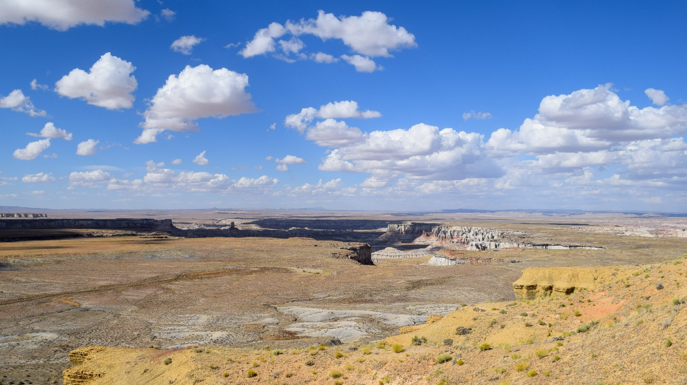
Landscape photo of Coal Mine Canyon in Coconino County, Arizona
Today, 567 Sovereign Nations across the entire U.S. have a formal nation-to-nation relationship with the U.S. government, with a total land mass of over 100 million acres.94F The Navajo Nation located in areas of Utah, Arizona, and New Mexico would be the 42nd largest state in the U.S., alone larger than states like Maryland, New Hampshire, and Hawaii. While tribal lands are exempted from Titles I and II of the ADA, there is legal precedent to suggest that Title III of the ADA applies to public accommodations in reservations.95F Further, federal elections funded with government dollars must fully comply with ADA’s regulations

DOJ SETTLEMENT AGREEMENT
In August 2016, as a part of the DOJ’s ADA Voting Initiative, the Department surveyed 31 of Coconino County’s 61 polling places. As with most jurisdictions, the DOJ found that many of Coconino County’s polling places were not ADA-compliant. Most of Coconino County’s polling places lacked van accessible parking, appropriate signage, and accessible door hardware.96F
Almost two years later, in May 2018, the DOJ announced a settlement agreement with Coconino County. As a result, Coconino County agreed to start adapting their polling places to ensure that all sites are accessible to people with disabilities before the November 2020 election.97F The agreement noted that the county is not limited “from making ADA-compliant, permanent modifications to its polling place locations instead of providing temporary remedial measures or relocating a polling place location.”98F
The DOJ settlement did not list how many of the polling places surveyed lacked ADA-compliance. Rather, the settlement states “that many of the County’s precincts and early voting locations are housed in polling places which contain barriers to access for persons with disabilities, and that Coconino County violated Title II by failing to select and use facilities as polling places on Election Day that are accessible to persons with disabilities.”99F However, Type Investigations (a program of Type Media Center, a nonprofit media center) reported in November 2018 that, following the settlement, Coconino County reviewed the additional polling places and found that 46 of the total 65 polling places at the time were not ADA-complaint.100F In other words, over half of the county’s polling places were, in some way, inaccessible to people with disabilities.
Following the news of the settlement agreement, the DOJ received accusations that it was targeting Coconino County and that DOJ enforcement would lead to polling place closures to suppress the Native American vote.101F Opponents expressed concerns that the Department’s efforts would hinder opening future polling places and early voting sites that serve Indigenous communities.102F

COCONINO COUNTY’S POLLING PLACES
As of September 2019, Coconino County has a total of 71 precincts, 54 polling places, and 3 vote centers (Tuba City High School, Flagstaff Mall, and J. Lawrence Walkup Skydome). The Sovereign Nations (Navajo, Hopi, the San Juan Southern Paiute, and the Havasupai Tribe) are located among 15 of the total precincts in the county. Thirteen polling places and two of the vote centers, Tuba City High School and Flagstaff Mall, serve the reservations as well.103F
The Leadership Conference reported that Coconino County’s polling places went from 64 to 55 between 2012 and 2018.104F During the 2016 Election, Coconino County had 61 polling places according to the DOJ, and in September 2019, Coconino County reported that they had 54 polling places. Coconino County stated the decrease in polling places was mostly as a result of consolidations, vote centers, and certain polling places that had to be closed because of safety concerns, including locations that were being condemned.105F
High Country News reported that following the settlement agreement with the DOJ, Coconino County had a total of five polling places that could not be updated to meet the requirements of the ADA and had to be relocated; the farthest moving roughly 10 miles away from its original location.106F According to the Coconino County’s election officials, the Inscription House polling place located on the Navajo Nation was just moved across the street based on request of the Chapter Manager. The polling place in Leupp’s Community building was closed in 2016 due to unsanitary conditions, while the polling place in Tonalea’s Chapter House was moved to a different building on the same Chapter House campus.
Election officials in Coconino County also opted to consolidate three of their polling places in Tuba City into one, as two of the polling places were no longer usable. Coconino County’s Tuba City Elementary School was new, but lacked sufficient parking, and became too crowded for it to be a polling place. Tuba City Junior High School’s polling place also had limited parking. As a result, Coconino County consolidated these two polling places with Tuba City’s high school. Tuba City Elementary School is approximately 1.6 miles away from the high school, while Tuba City Junior High School is about 1.8 miles from the high school.
According to Coconino County election officials, out of the 13 polling places located on tribal land — all of them required remediation in 2018 as none of them were fully ADA-compliant. All of the polling places were missing van accessible parking and appropriate signage. All of them were missing access aisles. Five of the 13 polling places had unpaved parking. Eight of the polling places had abrupt changes in ground levels. Four of them had inaccessible surface openings. Six of the polling places had inaccessible door hardware. One of the polling places had an improper threshold, while one of polling places had a non ADA-compliant ramp.107F

Cameron’s Polling Place
On Election Day, voters travel to Cameron’s Senior Center to cast their ballot. Voters have to drive on a gravel parking lot when turning off the main road next to the local Chapter House. At first glance, there is a concrete slab parking space in front of the building by the entrance. The concrete slab is designated as the polling place’s accessible parking and might seem to be a fully compliant permanent ADA accessible parking space. Unfortunately, the width of the lines designating the parking space are too narrow and there is no accessible parking signage. Temporary signage and orange parking cones on Election Day would correct these issues. Unfortunately, the slope of the concrete parking slab is also significantly too steep. Thus, an alternative temporary accessible parking space which is more level would need to be created.
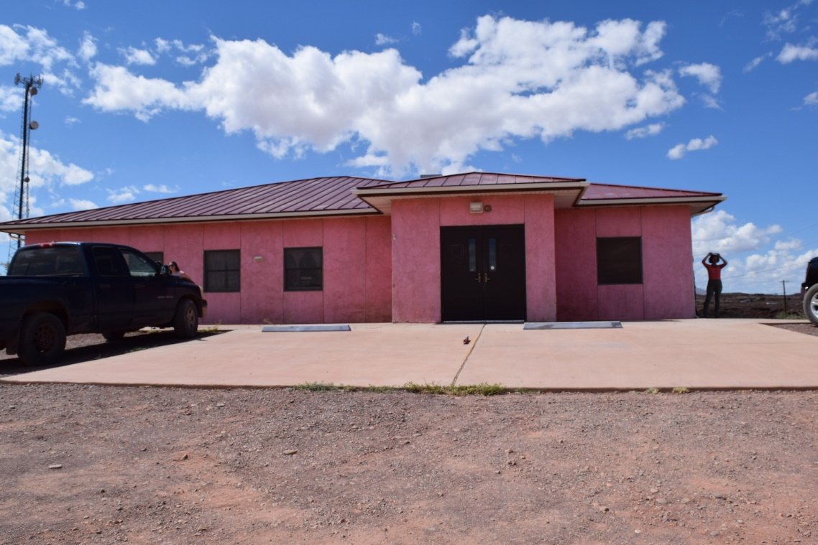
Polling site in Cameron, Arizona

Tuba City’s Polling Place
Tuba City High School is one of the county’s three vote centers, meaning anyone in Coconino County can vote there on Election Day. The polling place is located in the school’s gym, placing it far from the main entrance and creating issues regarding ADA-compliance, including accessible parking that is far from the gym entrance and a path of travel from the parking lot to the voting entrance with abrupt surface level changes.
In response to these ADA issues, Coconino County uses orange cones to designate accessible parking and places temporary signage to signify the accessible parking spaces as close as possible to the entrance to the gym. The county also places a ramp where the pathway to the voting area has abrupt level changes, including a curb where no curb cut exists. These low cost, temporary measures make this polling place accessible on Election Day and allow it to remain open.

Moenkopi’s Polling Place
Moenkopi Community Center, located on Hopi land, opens its doors to Coconino County election officials and voters on Election Day.108F The parking lot itself is gravel and lacks a van accessible parking space, along with access aisles with appropriate signage. Furthermore, the current door hardware requires gripping and twisting motion to open, which is not operable by all voters.
Fortunately, rather than moving Moenkopi’s polling place, Coconino County has put in place several temporary measures to improve accessibility, including placing orange cones and signage to designate an accessible parking space and providing a “Ballot Call” (door bell system) for individuals that prefer to vote curbside on Election Day, given that the gravel parking lot is not slip resistant. Election officials also place a temporary lever handle to assist voters in opening the door.

Coalmine’s Polling Place
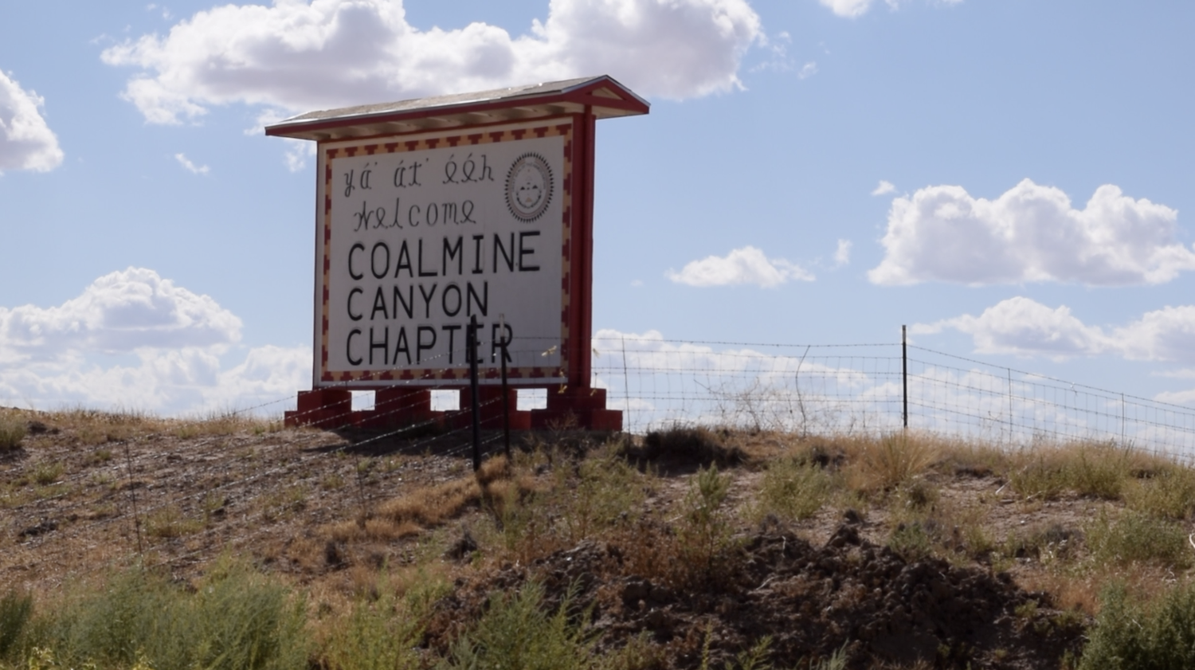
Large signage to Coalmine Canyon Chapter House.
Coalmine has a Chapter House that has served as a polling place for the past couple election cycles with no other public buildings for miles. With a concrete accessible parking slab and concrete sidewalks, it has worked well on Election Day for most. Unfortunately, the settling of the foundation beneath the Coalmine Chapter House has led to cracks in the building’s walls and ground, and the building is no longer safe for occupancy. Cracks are apparent on the sidewalks outside, and on some of building’s exterior walls. The interior floor slopes down at an odd angle. The bathrooms no longer work as a result of the foundation settling and people using the Chapter House have been using outhouses. As a result, Coalmine’s Chapter House will most likely not be a polling place during the next election and is an example of a polling place closure or relocation for public safety. Measures will have to be taken to ensure voter turnout, as the county is forced to move its polling place to one that is habitable. In addition to proper enforcement, funding is sorely needed for jurisdictions to support the maintenance of polling places and to support Sovereign Nations who are being impacted by the earth’s natural shift.

Coconino County’s Voter Participation Work
In recognition of the challenges that have surfaced in making Coconino County’s elections accessible for all, the county government and the county’s election officials are dedicated to ensuring that all people have the same right to vote, including people with disabilities and Native Americans. Within Coconino County and specifically on tribal land, such as Navajo and Hopi, elections staff hold regular voter participation events, voter registration drives, and present at Chapter and tribal meetings. Staff also ensure that all reservation voting locations have translators, and Coconino County has recruited several tribal election board members and election board staff to support this work. Collaboratively, staff have gone to great lengths to prevent poll closures, including re-roofing, repairing, and painting buildings on tribal land to create new polling places and even creating an outhouse for a polling place.

A CROSSROADS: Native American Rights and Disability Rights
Randolph County, Georgia provides a valuable lesson in combatting voter suppression across the U.S. – voting rights advocates cannot allow a divide and conquer strategy. Much the way Randolph County officials attempted to pit voters with disabilities against Black voters, the narrative surrounding Coconino County, Arizona threatens to position voters with disabilities and Native American voters as opponents in the struggle for equal access to the ballot.
Tribal lands in the U.S. are admittedly not required to follow all federal laws, including parts of the ADA.109F However, if counties such as Coconino County have polling places on tribal land — the polling places must be accessible during federal elections and when using government funds. Of course, the solution is not to remove all polling places from tribal land and reduce access to the ballot for Native Americans. Similarly, the solution cannot be to look the other way when polling places on reservations are not accessible as required under the ADA. In the end, Native Americans with disabilities have the same right as any other citizen in this country to participate in their democracy, on and off reservations, and solutions and compromises must be found to protect their rights.
Curbside voting has been a “go to” compromise on tribal lands. Proponents argue that polling places on reservations do not have to be ADA-complaint, as a person with a disability can just vote by having a ballot brought to them outside the inaccessible location. In the long journey to making America’s polling places accessible, curbside voting has indeed been an important stop gap measure – providing access for voters with disabilities on Election Day as while elections officials work to make their polling places accessible. That said, the ADA is clear that curbside voting can only be used in limited circumstances and that people with disabilities must be given the same terms and level of privacy to vote as other voters. There is also evidence to show that they are committed to voting alongside their non-disabled peers. In a national poll conducted in 2019, roughly 90 percent of voters with disabilities felt it was important to vote privately, independently, and in the same manner as other voters.110F
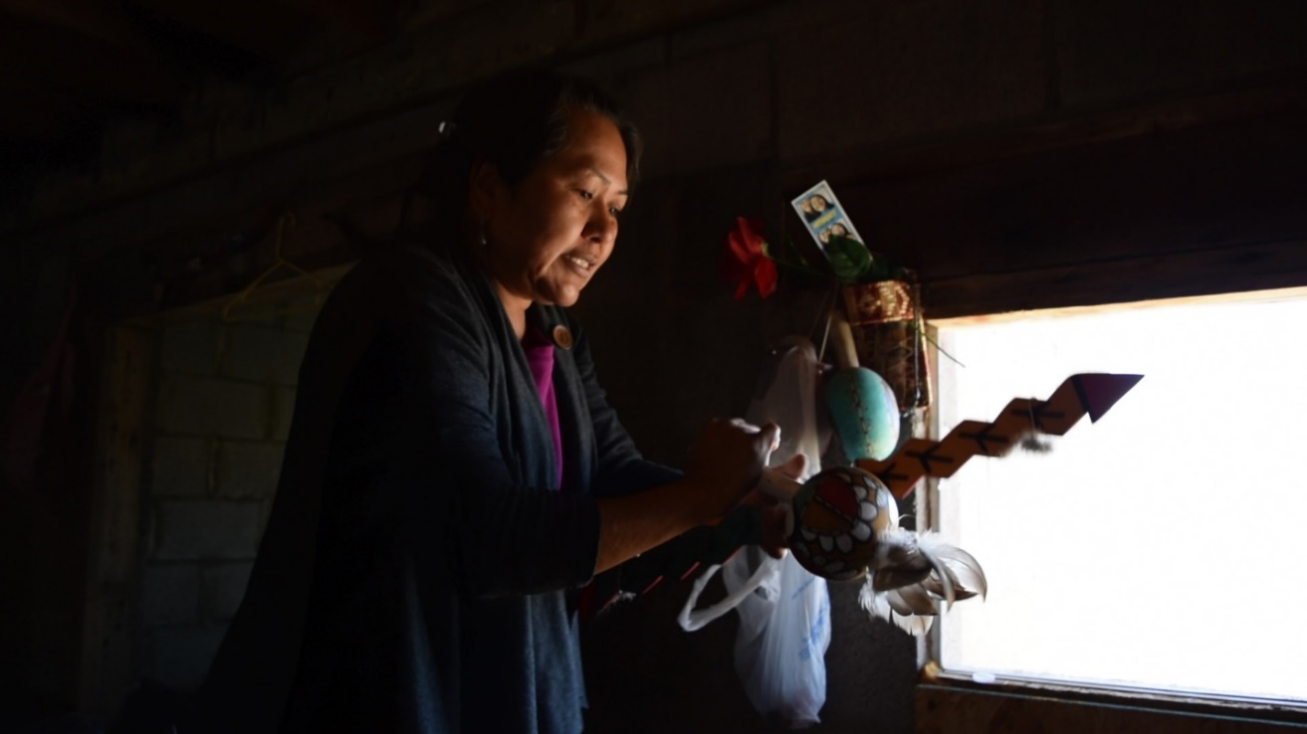
Twila Honyaoma of the Hopi tribe holds out traditional gourd shaker.

CONCLUSION
Coconino County provides potentially the most complex case study in the interplay between elections administration, the ADA, and DOJ enforcement. Admittedly, Coconino County has experienced poll closures following the Shelby County decision and the county’s settlement with the DOJ. Yet, the impetus for closures are broader than ADA-compliance, including lack of capacity to process voters and building foreclosures. Further, elections staff in Coconino County are diverse and include leadership from the Native American communities for whom polling place closures threaten access. Coconino County appears to be working actively to prevent closure and relocation of polling places, in a challenging environment. Fundamentally, the ADA is only as strong as its ability to protect the rights of people with disabilities wherever they live, work, play, and vote in the United States. DOJ enforcement in environments that are already compliant or in which easy solutions are readily available does not strengthen the ADA or its practical protection of the rights of people with disabilities in their communities. In fact, DOJ’s enforcement of the ADA is only as strong as its ability to drive innovative solutions in the most challenging environments.

PRACTICAL SOLUTIONS: MAKING POLLING PLACES ACCESSIBLE & AVOIDING CLOSURES
Resistance to DOJ intervention raises some red flags – unveiling a large-scale unfamiliarity with the ADA’s provisions and the Act’s unearned reputation for forcing costly fixes. The detail and complexity of the ADA’s accessibility regulations clearly drives this kind of misinformation, which can easily be leveraged by jurisdictions looking to close polling places either to save money or influence voter turnout. Audiences unfamiliar with the ADA and what it actually takes to be accessible on Election Day are ill-prepared to combat narratives designed to necessitate poll closures.
P&A agencies can provide a wealth of knowledge and support to jurisdictions seeking to achieve access for all.
The law is clear — all polling places need to be accessible; however, the intent of the ADA is not to close or remotely relocate polling places. While a small number of closures, consolidations, and relocations in the immediate vicinity are inevitable, jurisdictions can use a mix of temporary and permanent changes to make elections accessible under the ADA. The example set by the Jefferson County, Alabama church, which was able to construct a ramp through a combination of donated materials and volunteer labor, proves that even permanent ADA modifications can be made at little to no cost.
Where this is not possible, jurisdictions can temporarily make polling places accessible on Election Day. This can be as simple as creating accessible parking spots with orange cones and temporary signs. These solutions are low cost and well below the inflated estimates offered by some election administrators as an impetus for poll closures. Further, temporary modifications allow election administrators to purchase and keep their own supply of materials and deploy them where needed on Election Day.
If temporary fixes will not bring the location into compliance, then and only then, should a jurisdiction consider relocating the polling place. If the polling place must be relocated, it is crucial to receive input from all impacted stakeholders, including the disability community and other voters, to ensure that the relocation of the polling place will not suppress voter participation.

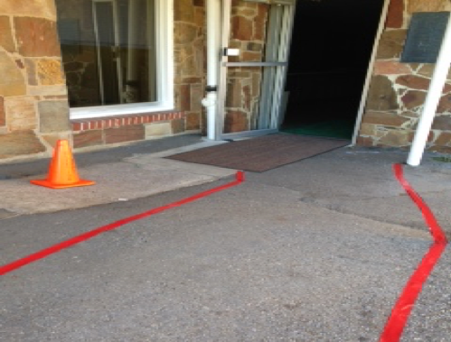
Temporary Remedies to Polling Places
Permanent remedies to polling place access are generally more desirable because they will continue to provide access for all community members in typically public spaces every day of the year, rather than just on Election Day. However, temporary remedies to polling places should be used if permanent fixes are not feasible. Although not designed to be permanent solutions, the following tools can be used to provide remedies on Election Day to improve accessibility. These tools can often be found in local hardware and home improvement stores or online for reasonable cost.
Duct tape designates access aisle as temporary measure. Photo courtesy of Disability Rights Texas.

Parking
If a polling place does not have any designated accessible parking, election officials, volunteers, or poll workers can either paint boundary lines, place traffic cones, or use tape to mark off boundary lines for accessible parking. In other words, if parking is available at the polling place, accessible parking must be available and can be “created” at minimum cost.
To be ADA-compliant, accessible parking spaces must also have designated signage, and temporary signs can be made with little effort. Elections staff can paint a sign using poster board or cardboard with the international symbol of accessibility and tape it on a pole (if located in front of the accessible parking spot) or place the sign on a cone in front of the parking space. If the parking space is specifically for lift or ramp equipped van accessible parking, the sign must include the words “Van Accessible” somewhere as well.

Ramps
If polling places have stairs with no available ramps, temporary ramps with edge protection can often make the location accessible. Ramps can provide access to sidewalks and building entrances. However, it is important to remember that portable ramps that are not permanently connected to the structure and without handrails cannot be used if the vertical rise is greater than six inches. Ramps with a vertical rise greater than six inches must have handrails.
Wedge ramps can also give access to people if thresholds are too high and if there are slight changes in level, such as big cracks in the sidewalks. Rubberized mats can also provide access over broken pavement that creates inaccessible surface changes, as well as over thresholds that exceed the one half inch ADA standards.

Doors
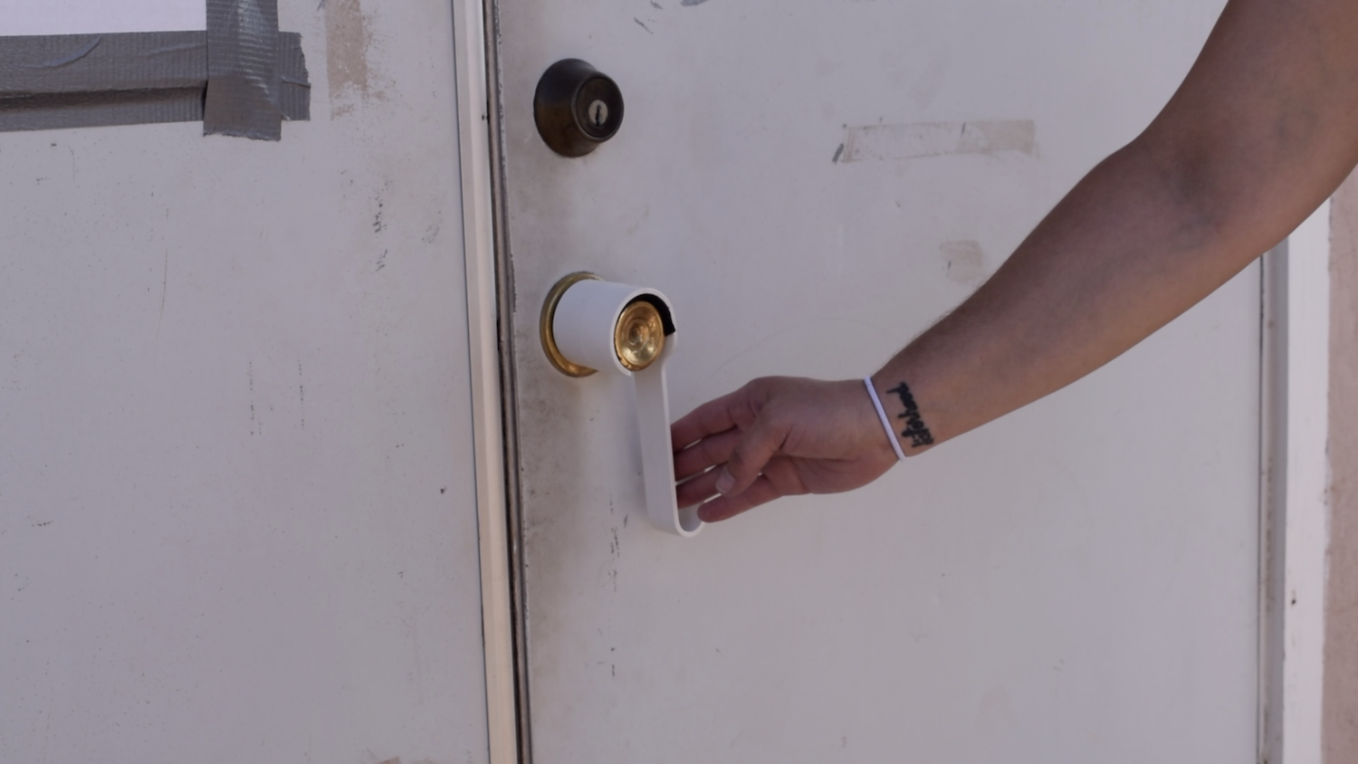
Round doorknob is outfitted with a retrofitted lever knob.
Many door handles are not accessible. If doorways to do not have automatic door openers, doors should be openable by using one hand and should not require tight grasping, pinching, or twisting of the wrist.111F If this is the case, polling places can use “retro-fitted lever knobs.” These retrofitted levers fit over existing round knobs. However if this is not an option, polling places can prop open doors on Election Day. Standard doorstops can be used to achieve this as well.

Water Fountains and Protruding Objects
Hallways at polling places might not always be fully accessible. For example, water fountains, fire extinguisher boxes, and display cases that stick out of the wall are not detectible for people who use white canes. However, election officials can place detectable objects, such as traffic cones or other skirting objects to make these protruding objects detectable for voters who are blind or low vision.

Relocating Polling Places
When counties and cities discuss relocating polling places they must consider many factors including safety and distance. However, it is important to note that sometimes jurisdictions have no other option, for instance when long-term polling places decline to serve again, are undergoing construction or renovation, or are condemned or foreclosed upon, then election officials’ only option is to relocate. Notably, the U.S. is seeing an increase in schools that no longer want to serve as polling places for security concerns following multiple incidences of gun violence in and around schools, and if that is the case, jurisdictions again have no choice but to relocate a polling place.112F
If a jurisdiction needs to relocate a polling site, election officials should work with the community to locate the best option. Facilitating communication with the voters and working with community leaders and groups can help find the best solution, can prevent unintended hardship on voters, and can reduce overall costs. Disability rights organizations and people with disabilities, especially if a polling place is being relocated because of ADA concerns, must be brought to the table. P&A agencies can provide a wealth of knowledge and support to jurisdictions seeking to achieve access for all.

Consolidating Polling Places
Consolidation of polling places can be an appropriate remedy in some cases. For example, two polling places in immediate proximity, such as a community’s middle school and elementary school, may make sense to combine if one location is significantly more accessible than the other. Of course, the surviving polling place must have the appropriate capacity to take the new influx of voters. Extreme consolidations, i.e. pairing 40 polling places down to two, is typically not recommended unless all 40 polling places were in very close proximity and the remaining two are being used as vote centers – an admittedly unlikely scenario.

“Accessible” Poll Workers
Even the most ideal polling places are only as accessible as the poll workers that run them on Election Day. With minimal training and high expectations for job performance, providing effective and timely accommodation to voters with disabilities can be daunting for polling place staff. Jurisdictions that have the capacity should consider a dedicated poll worker whose mission is to ensure equal access for all at the polls. In other words, every polling place should assign a poll worker whose main Election Day duty is to support voters with disabilities who might be unaware of the accessibility features available to cast a ballot and their rights for accommodation, or who otherwise need assistance. A poll worker with this specialization can also ensure that the polling place is set up to be fully compliant with the ADA and enact any necessary same-day modifications. Although poll workers are frequently in short supply, the “accessible” poll worker can perform regular job functions in addition to serving as a specialist.

“Accessible” Money
Responsibility for ADA-compliance at polling places falls exclusively with the local jurisdictions that are responsible for recruiting and planning polling sites. No elections office with a desire to comply or facing DOJ intervention should be limited by a lack of funding. The federal government must accept its role in providing a continual funding stream to state and local election officials for the purpose of making electoral processes fully accessible. Following the passage of the Help America Vote Act (HAVA), many states received funding to give to jurisdictions to ensure polling place accessibility, and these funds should be fully reinstated.113F
In order to provide jurisdictions with funding to make their polling places accessible, Congress must renew funding through the HAVA grant program to ensure voting access for individuals with disabilities. Jurisdictions that are not ADA-compliant and lack the funding to make necessary improvements simply dismiss the need to comply with the law.
Congress must also fully fund the Protection and Advocacy for Voter Access (PAVA) program, created by HAVA, the P&As have a federal mandate to “ensure the full participation in the electoral process for individuals with disabilities, including registering to vote, casting a vote and accessing polling places.”114F The PAVA program has had a positive impact on the accessibility of polling places since its creation in 2002. Yet, as a nationwide program, limited funding has restricted the overall positive impact. Since the creation of the PAVA program, overall funding per year has never exceeded $7 million. Spread currently across 55 P&As, this has limited the amount of work the PAVA program can do each year.

CONCLUSION
America’s democracy is only as strong as its ability to hear the voices of all Americans.
There is no denying that these are complex problems, and the solutions to providing voter access are as broad and diverse as the disability community itself. However, the nation must find creative solutions in order to come to an agreement and move forward. Americans must educate each other about disability and disability rights, and work together to ensure equal access at polling places and at the ballot box.
Aggregated data around the number of polling places in use in the United States provides no clear answers on the threat of polling place closure to voter participation. Exploration of electoral jurisdictions on a case-by-case basis reveals two very different narratives.
Overwhelmingly, reviewed jurisdictions that entered into settlement agreements with the DOJ are working diligently to improve their ADA-compliance while preventing unnecessary polling place closures. In stark contrast, all of the jurisdictions reviewed who blamed recent poll closures on the ADA: were not experiencing DOJ intervention at the time, provided little to no evidence of DOJ-sanctioned ADA surveys or coordination with the disability community, displayed an apparent lack of understanding of the ADA’s provisions, and took action to close polling places after the Shelby County decision was handed down. There are essentially two types of jurisdictions whose motives have been called into question: 1) jurisdictions with DOJ settlements who are working hard to ensure voter access and ample polling locations and 2) jurisdictions closing and relocating polling places with no demonstrable impetus from the ADA, despite claims to the contrary. Each necessitates a distinct response.
Jurisdictions working with DOJ to resolve ADA violations should actively engage with disability rights advocates and accessibility experts to find creative solutions to complex problems. Although temporary modifications help cap costs, jurisdictions with a demonstrated desire to improve their accessibility should be eligible for renewed federal funding to make an enhanced menu of all accessibility solutions at various price-points, including permanent modifications, achievable. DOJ enforcement of the ADA is the first line of defense in making America’s polling places accessible to all eligible voters and should continue to be used as such.
The six years following the Shelby County decision have proven that voter suppression in the U.S. is alive and well. Randolph County, Georgia, is the most widely known and egregious example, but as this report highlights, it is not the only example. Jurisdictions that act quickly to close and relocate polling places with a disparate impact on voters and little to no evidence that the ADA requires such action open themselves to litigation under the VRA. However, litigation can only be used to combat voter suppression after it occurs, and is a long and costly process. Litigation is insufficient to prevent voter suppression before it can have a decimating effect. The VRA must be fully restored to prevent discriminatory poll closures before they take effect.
America’s polling places and electoral systems, as a whole, must be accessible to safeguard equal access to the ballot box. America’s democracy is only as strong as its ability to hear the voices of all Americans.

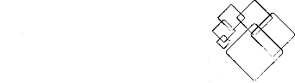
Find the P&A in your state or territory at NDRN.org
National Disability Rights Network
820 First Street NE, Suite 740
Washington, DC 20002
Phone: (202) 408-9514
Fax: (202) 408-9520
TDD/TTY: (202) 408-9521

Twitter: @NDRNadvocates
Facebook: facebook.com/NDRNadvocates

Help America Vote Act of 2002, Pub. L. No. 107-252, 116 Stat. 1666 (2002).
“ADA Checklist for Polling Places.” ADA.gov. U.S. Department of Justice, Civil Rights Division Disability Rights Section. https://www.ada.gov/votingck.htm.
Brault, Matthew. “Americans with Disabilities: 2010, Household Economic Studies, Current Population Reports.” U.S. Department of Commerce, Economics and Statistics Administration, U.S. Census Bureau, July 2012. https://www2.census.gov/library/publications/2012/demo/p70-131.pdf.
Okoro, Catherine, NaTasha Hollis, Alissa Cyrus and Shannon Griffin-Blake. “Prevalence of Disabilities and Health Care Access by Disability Status and Type Among Adults — United States, 2016.“ U.S. Department of Health and Human Services, Centers for Disease Control and Prevention. August 2018. http://dx.doi.org/10.15585/mmwr.mm6732a3.
Bialik, Kristen. “7 Facts about Americans with Disabilities.” Pew Research Center. July 2017. https://www.pewresearch.org/fact-tank/2017/07/27/7-facts-about-americans-with-disabilities/.
Schur, Lisa and Douglas Kruse. “Projecting the Number of Eligible Voters with Disabilities in the November 2016 Elections.“ Rutgers University. September 2016. https://smlr.rutgers.edu/sites/default/files/documents/faculty_staff_docs/Kruse%20and%20Schur_Disability%20electorate%20projections%202016_9-8-16.pdf.
“The Americans with Disabilities Act and Other Federal Laws Protecting the Rights of Voters with Disabilities.” ADA.gov. U.S. Department of Justice Civil Rights Division, Disability Rights Section. September 2014. https://www.ada.gov/ada_voting/ada_voting_ta.htm.
“The Americans with Disabilities Act and Other Federal Laws Protecting the Rights of Voters with Disabilities.” ADA.gov. U.S. Department of Justice, Civil Rights Division Disability Rights Section. https://www.justice.gov/file/69411/download.
While Section 504 of the Rehabilitation Act of 1973 provided that, “No otherwise qualified individual with a disability . . . shall, solely by reason of his or her disability, be excluded from participation in, be denied the benefits of, or be subjected to discrimination under any program or activity receiving Federal financial assistance . . . , 29 U.S.C. § 794(a), it was limited to entities receiving Federal financial assistance. Thus, polling places in government offices, schools or other government facilities constructed or operated with Federal financial assistance needed to be made accessible under Section 504. However, a significant number of polling places continue to be located in entities that do not receive federal funding and are only reached by the ADA’s coverage of public accommodations, like theaters, arenas, and other meeting spaces.
Bush, George H.W.”Signing of the Americans with Disabilities Act.” White House, Washington, DC. July 1990. https://www.eeoc.gov/eeoc/history/35th/videos/ada_signing_text.html.
“Solutions for Five Common ADA Access Problems at Polling Places.” ADA.gov. U.S. Department of Justice, Civil Rights Division, Disability Rights Section. https://www.ada.gov/ada_voting/voting_solutions_ta/polling_place_solutions.pdf.
”ADA Accessibility Guidelines (ADAAG).“ Access-board.gov. United States Access Board. September 2002. https://www.access-board.gov/guidelines-and-standards/buildings-and-sites/about-the-ada-standards/background/adaag.
”Vocational Rehabilitation Policies and Procedures Manual.” The Department of Health and Human Services, North Carolina. https://www2.ncdhhs.gov/info/olm/manuals/dsb/VR/man/Voter%20Registration.htm.
“The Americans with Disabilities Act and Other Federal Laws Protecting the Rights of Voters with Disabilities.” ADA.gov. U.S. Department of Justice, Civil Rights Division, Disability Rights Section. September 2014. https://www.ada.gov/ada_voting/ada_voting_ta.htm.
“The Americans with Disabilities Act and Other Federal Laws Protecting the Rights of Voters with Disabilities.” ADA.gov. U.S. Department of Justice, Civil Rights Division, Disability Rights Section. September 2014. https://www.ada.gov/ada_voting/ada_voting_ta.htm.
U.S. Government Accountability Office. gao.gov. https://www.gao.gov/.
”Voters with Disabilities: Observations on Polling Place Accessibility and Related Federal Guidance.” gao.gov. U.S. Government Accountability Office. October 2017. https://www.gao.gov/assets/690/687556.pdf.
”Voters with Disabilities: Observations on Polling Place Accessibility and Related Federal Guidance.” gao.gov. U.S. Government Accountability Office. October 2017. https://www.gao.gov/assets/690/687556.pdf.
“The Continued Suppression of Voters with Disabilities in South Carolina.” Protection and Advocacy for People with Disabilities, Inc. October 2019. https://www.pandasc.org/wp-content/uploads/2019/10/The-Continued-Suppression-of-Voters-with-Disabilities.pdf.
“The Continued Suppression of Voters with Disabilities in South Carolina.” Protection and Advocacy for People with Disabilities, Inc. October 2019. https://www.pandasc.org/wp-content/uploads/2019/10/The-Continued-Suppression-of-Voters-with-Disabilities.pdf.
”DC Voting Access Report on the June 19, 2018 Primary Election.“ Disability Rights DC. June 2018. http://www.uls-dc.org/media/1165/drdc-dc-voting-access-report-june-19-primary.pdf.
”Help Arkansas Vote: A Survey of Polling Place Accessibility.” Disability Rights Arkansas. August 2019. https://disabilityrightsar.org/wp-content/uploads/2018/10/DRA-Voting-Report.pdf.
”Help Arkansas Vote: A Survey of Polling Place Accessibility.” Disability Rights Arkansas. August 2019. https://disabilityrightsar.org/wp-content/uploads/2018/10/DRA-Voting-Report.pdf.
”Religious Entities Under the Americans with Disabilities Act.” ADAta.org. ADA National Network. January 2020. https://adata.org/factsheet/religious-entities-under-americans-disabilities-act.
”The Fundamental Principal of a Participatory Democracy.” Native American Disability Law Center. May 2013. https://www.ndrn.org/wp-content/uploads/2019/10/Polling-Accessibility-Report-00000005.pdf.
”The Fundamental Principal of a Participatory Democracy.” Native American Disability Law Center. May 2013. https://www.ndrn.org/wp-content/uploads/2019/10/Polling-Accessibility-Report-00000005.pdf.
Broadway, Molly. Molly Broadway to the Honorable Nicole Crocker, Callahan County, September 12, 2019. Letter. From Disability Rights Texas.
Broadway, Molly (HAVA Training & Technical Support Specialist, Disability Rights Texas) in discussion with NDRN, July 2019.
”Statewide Accessibility Survey Results of Vermont Polling Places.” Disability Rights Vermont. July 2018. http://www.disabilityrightsvt.org/pdfs/Press_releases/Statewide-Accessibility-Results.pdf.
”Section 203 Language Determinations.” U.S. Department of Commerce, U.S. Census Bureau. May 2017. https://www.census.gov/programs-surveys/decennial-census/about/voting-rights/voting-rights-determination-file.html.
”The Language Minority Provisions of the Voting Rights Act.” ADA.gov. U.S. Department of Justice, Civil Rights Division. Justice.gov. March 2019. https://www.justice.gov/crt/about-language-minority-voting-rights.
“The Americans with Disabilities Act and Other Federal Laws Protecting the Rights of Voters with Disabilities” ADA.gov. U.S. Department of Justice, Civil Rights Division, Disability Rights Section. September 2014. https://www.ada.gov/ada_voting/ada_voting_ta.htm.
“ASL Voter Hotline.” National Association of the Deaf. nad.gov. Accessed January 24, 2020. https://www.nad.org/asl-voter-hotline/.
”Use plain language.” Harvard University. Accessed January 24, 2020. https://accessibility.huit.harvard.edu/use-plain-language.
Landreth, Natalie. “Why Should Some Native Americans Have to Drive 163 Miles to Vote?” The Guardian. June 2015. https://www.theguardian.com/commentisfree/2015/jun/10/native-americans-voting-rights.
Caranci, Paul. ”Accessible Absentee Balloting: It’s Not Just the Law, It’s the Right Thing to Do.” National Association of Secretaries of States. July 2018. https://www.nass.org/sites/default/files/2018-07/democracy-live-white-paper-nass-summer18.pdf.
Caranci, Paul. ”Accessible Absentee Balloting: It’s Not Just the Law, It’s the Right Thing to Do.” National Association of Secretaries of States. July 2018. https://www.nass.org/sites/default/files/2018-07/democracy-live-white-paper-nass-summer18.pdf.
"Shelby County v. Holder." Oyez. Accessed January 24, 2020. https://www.oyez.org/cases/2012/12-96.
“Section 4 of the Voting Rights Act.” justice.gov. U.S. Department of Justice, Civil Rights Division. December 2017. https://www.justice.gov/crt/section-4-voting-rights-act
Chapman, Leigh, Caitlin Hatakeyama, Ashley Lawrence, Tyler Lewis, Scott Simpson, and Jiayu Wang. ”Democracy Diverted: Polling Place Closures and the Right to Vote.“ The Leadership Conference Education Fund. September 2019. https://civilrights.org/democracy-diverted/.
“Polling Place and Vote Center Management.“ eac.gov. U.S. Election Assistance Commission. Accessed January 24, 2020. https://www.eac.gov/sites/default/files/eac_assets/1/6/Chapter_9_Polling_Place_and_Vote_Center_Management.pdf.
”Election Administration And Voting Survey 2018 Comprehensive Report. A Report to the 116th Congress.” eac.gov. U.S. Election Assistance Commission. July 2019. https://www.eac.gov/assets/1/6/2018_EAVS_Report.pdf.
Chapman, Leigh, Caitlin Hatakeyama, Ashley Lawrence, Tyler Lewis, Scott Simpson, and Jiayu Wang. ”Democracy Diverted: Polling Place Closures and the Right to Vote.“ The Leadership Conference Education Fund. September 2019. https://civilrights.org/democracy-diverted/.
Blackwell, Victor, Devon Sayers and Pamela Kirkland. ”Elections Board Takes Less than a Minute to Reject Proposal to Close 7 of 9 Polling Places in Majority-Black County.” CNN. August 2018. https://www.cnn.com/2018/08/24/us/randolph-county-polling-closures-vote/index.html.
Schallhorn, Kaitlyn. ”Georgia under Scrutiny for Alleged Voter Suppression: What's Going on?” Fox News. October 2018. https://www.foxnews.com/politics/georgia-under-scrutiny-for-alleged-voter-suppression-whats-going-on.
Williams, Vanessa. ”Majority-Black Georgia County Fires Consultant who Wants to Close Two-Thirds of its Polling Places.” Washington Post. August 2018. https://www.washingtonpost.com/news/powerpost/wp/2018/08/23/majority-black-georgia-county-fires-consultant-who-wants-to-close-two-thirds-of-its-polling-places/.
Kauffman, Johnny. ”This Georgia County May Close All But 2 Polling Places” NPR. August 2018. https://www.npr.org/2018/08/23/641201292/this-georgia-county-may-close-all-but-two-polling-places.
Kauffman, Johnny. ”Georgia County Votes To Keep Polling Places Open After Intense Scrutiny.” NPR. August 2018. https://www.npr.org/2018/08/24/641556969/georgia-county-votes-to-keep-polling-places-open-after-intense-scruitney.
Shah, Khushbu. ”Textbook voter suppression': Georgia's Bitter Election a Battle Years in the Making.“ The Guardian. November 2018. https://www.theguardian.com/us-news/2018/nov/10/georgia-election-recount-stacey-abrams-brian-kemp.
“Americans with Disabilities Act Author: Kemp Has Failed to Comply with ADA.“ Georgia Democrats. August 2018. https://www.georgiademocrat.org/kemp-ada/.
Bishop, Michelle. ”The GOP Is Scapegoating People With Disabilities To Keep Black Voters From The Polls.“ HuffPost. November 2018. https://www.huffpost.com/entry/opinion-georgia-voter-suppression-black-voters-disabilities_n_5bd08899e4b0a8f17ef30c96.
The Arc Georgia's Facebook Page. November 2019. https://www.facebook.com/thearcga/posts/the-arc-ga-responded-to-news-that-election-officials-in-randolph-county-are-plan/10155491541052540/.
”Disability Groups Reject Racist Georgia Voter Suppression.“ Workers World. September 2018. https://www.workers.org/2018/09/38968/.
Kauffman, Johnny. ”Activists Wary As South Georgia County Moves To Close Three Polling Places.“ NPR. July 2018. https://www.wabe.org/activists-wary-as-south-georgia-county-moves-to-close-three-polling-places/.
Niesse, Mark. ”Precinct Closures in Rural Georgia Approved by County Elections Board.“ The Atlanta Journal-Constitution. August 2018. https://www.ajc.com/news/state--regional-govt--politics/precinct-closures-rural-georgia.
Purcell, Joy. ”Elections Board Focuses on Process Improvement.” Now Habersham. December 2014. https://nowhabersham.com/elections-board-focuses-on-process-improvement/.
Chapman, Leigh, Caitlin Hatakeyama, Ashley Lawrence, Tyler Lewis, Scott Simpson, and Jiayu Wang. ”Democracy Diverted: Polling Place Closures and the Right to Vote.“ The Leadership Conference Education Fund. September 2019. https://civilrights.org/democracy-diverted/.
Whitesides, John. ”Polling places become Battleground in US Voting Rights Fight.” Reuters. September 2016. https://www.aol.com/article/news/2016/09/16.
Meitzler, Carey. ”New Voting Precincts Finalized for Pearl River County.“ WRJW Radio. October 2017. https://www.wrjwradio.com/single-post/2017/10/19/New-voting-precincts-finalized.
Meitzler, Carey. ”New Voting Precincts Finalized for Pearl River County.“ WRJW Radio. October 2017. https://www.wrjwradio.com/single-post/2017/10/19/New-voting-precincts-finalized-for-Pearl-River-County.
Smith, Cassie. ”County to Move to Vote Center in East Waco for ADA, School Security Concerns.” Waco Tribune-Herald. July 2018. https://www.wacotrib.com/news/elections/county-to-move-vote-center-in-east-waco-for-ada.
Smith, Cassie. ”County to Move to Vote Center in East Waco for ADA, School Security Concerns.” Waco Tribune-Herald. July 2018. https://www.wacotrib.com/news/elections/county-to-move-vote-center-in-east-waco-for-ada/article.
Marroni, Steve. ”Dauphin County Polling Places Changing for Disabled-Voter Accessibility.” PennLive. January 2019. https://www.pennlive.com/news/2018/03/dauphin_county_polling_place_c.html.
Sinett, Caitlin. “Baxter County, Arkansas Looking to Switch to Voting Centers.“ KY3. August 2018. https://www.ky3.com/content/news/Baxter-County-Arkansas-looking-to-switch-to-voting.
”Jefferson Parish Moving More than Two Dozen Polling Sites to Meet ADA Regulations.” NOLA. October 2018. https://www.nola.com/news/communities/east_jefferson/article.
Purpura, Paul. “Kenner Woman Sues Jefferson Parish to Get Better Access for Disabled Voters.“ The Times-Picayune. June 2010. https://www.nola.com/news/politics/article_161b7c7c-5571-5f6a-a376-39e62d4d2f1c.html.
”Jefferson Parish Moving More than Two Dozen Polling Sites to Meet ADA Regulations.“ The Times-Picayune. October 2015. https://www.nola.com/news/communities/east_jefferson/article_9eb7cdb5-9c73-5f65-9852-cd8f2311f31b.html.
Martz, Linda. ”Voting Precincts Not Up to ADA Snuff.“ Mansfield News Journal. September 2015. https://www.mansfieldnewsjournal.com/story/news/politics/elections.
Martz, Linda. ”Voting Precincts Not Up to ADA Snuff.“ Mansfield News Journal. September 2015. https://www.mansfieldnewsjournal.com/story/news/politics/elections.
Terzi, Matt. ”The Weaponized ADA: Using a Civil Rights Law to Disenfranchise Voters.” Ability Magazine. Accessed January 24, 2020. https://abilitymagazine.com/weaponized-ada-disenfranchised-voters/.
Lerner, Kira. ”The ADA is Being Used to Disenfranchise Minority Voters.” Think Progress. August 2018. https://thinkprogress.org/ada-voter-suppression-cd7031080bfd/.
”Project Civic Access Fact Sheet.” ADA.gov. U.S. Department of Justice, Civil Rights Division, Disability Rights Section. Accessed January 24, 2020. https://www.ada.gov/civicfac.htm.
Taylor, Barry and Bebe Novich (Equip for Equality Staff) in discussion with NDRN, July 2019.
Stephenson, Barry (Jefferson County Board of Registrars) in discussion with NDRN, July 2019.
Stephenson, Barry (Jefferson County Board of Registrars) in discussion with NDRN, July 2019.
Stephenson, Barry (Jefferson County Board of Registrars) in discussion with NDRN, July 2019.
Stephenson, Barry (Jefferson County Board of Registrars) in discussion with NDRN, July 2019.
”United States Announces Settlement with Richland County Board of Elections & Voter Registration to Ensure Compliance with Americans with Disabilities Act.” Department of Justice, U.S. Attorney’s Office, District of South Carolina. Accessed January 24, 2020. https://www.justice.gov/usao-sc/pr/united-states-announces-settlement-richland-county-board-elections-voter-registration.
”United States of America and Richland County Board of Elections and Voter Registration, South Carolina Regarding the Accessibility of Polling Places.” DJ # 204-67-173. ADA.gov. Accessed January 24, 2020. https://www.ada.gov/richland_county_sa.html.
”United States of America and Richland County Board of Elections and Voter Registration, South Carolina Regarding the Accessibility of Polling Places.” DJ # 204-67-173. ADA.gov. Accessed January 24, 2020. https://www.ada.gov/richland_county_sa.html.
Knowles, Maggie (Protection & Advocacy for People with Disabilities, Inc.) in discussion with NDRN, July 2019.
”United States Attorney Announces Settlement with Anderson County Board of Voter Registration and Elections to Ensure Compliance with Americans with Disabilities Act.” justice.gov. Department of Justice, U.S. Attorney’s Office, District of South Carolina. November 2018. https://www.justice.gov/usao-sc.
Smith, Katy (Anderson County's Elections Director) in discussion with NDRN, July 2019.
Mayo, Nikie. ”Anderson County Must Make Polling Places Accessible to Disabled Voters, Settlement Says.” Anderson Independent Mail. November 2018. https://www.independentmail.com/story/news/2018/11/16/disabled-voters-must-have-access-anderson-county-settlement-says/2024893002/.
Mayo, Nikie. ”Anderson County Must Make Polling Places Accessible to Disabled Voters, Settlement Says.” Anderson Independent Mail. November 2018. https://www.independentmail.com/story/news/2018/11/16/disabled-voters-must-have-access-anderson-county-settlement-says/2024893002/.
”Justice Department Reaches Agreement with Harris County, Texas, to Ensure Polling Place Accessibility for Voters with Disabilities." justice.gov. Department of Justice, Office of Public Affairs. March 2019. https://www.justice.gov/opa/pr/justice-department-reaches-agreement-harris-county-texas-ensure-polling-place-accessibility.
Justice Department Reaches Agreement with Harris County, Texas, to Ensure Polling Place Accessibility for Voters with Disabilities." justice.gov. Department of Justice, Office of Public Affairs. March 2019. https://www.justice.gov/opa/pr/justice-department-reaches-agreement-harris-county.
Broadway, Molly (HAVA Training & Technical Support Specialist, Disability Rights Texas) in discussion with NDRN, July 2019.
”Settlement Agreement between the United States of America and the City of Chesapeake Regarding the Accessibility of Polling Places. ADA.gov. May 2017. https://www.ada.gov/chesapeake_va_sa.html.
”Justice Department Reaches Agreement with McKinley County, New Mexico, to Ensure Accessible Voting.“ Department of Justice, Office of Public Affairs. June. 2019.https://www.justice.gov/opa/pr/justice-department-reaches-agreement-mckinley
”Justice Department Reaches Agreement with McKinley County, New Mexico, to Ensure Accessible Voting.“ justice.gov. Department of Justice, Office of Public Affairs. June. 2019. https://www.justice.gov/opa/pr/justice-department-reaches-agreement-mckinley.
”QuickFacts, Coconino County, Arizona.“ U.S. Department of Commerce, U.S. Census Bureau, American Community Survey. July 2018. https://www.census.gov/quickfacts/coconinocountyarizona.
Little, Becky. ”Native Americans Weren't Guaranteed the Right to Vote in Every State Until 1962.“ History. August 2019. https://www.history.com/news/native-american-voting-rights-citizenship.
Little, Becky. ”Native Americans Weren't Guaranteed the Right to Vote in Every State Until 1962.“ History. August 2019. https://www.history.com/news/native-american-voting-rights-citizenship.
”Tribal Nations and the United States: An Introduction.” National Congress of American Indians. May 2019. http://www.ncai.org/tribalnations/introduction/Tribal_Nations_and_the_United_States_An_Introduction-web-.pdf.
”Federal Disability Rights Laws as Applied to Native American Tribes.” Southwest ADA Center. June 2003. http://www.southwestada.org/html/publications/ebulletins/legal/2003/may2003b.html.
”Justice Department Reaches Agreement with Coconino County, Arizona, to Ensure Accessible Voting.“ justice.gov. U.S. Department of Justice, Office of Public Affairs. May 2018. https://www.justice.gov/opa/pr/justice-department-reaches-agreement-coconino-county-arizona-ensure-accessible-voting.
”Justice Department Reaches Agreement with Coconino County, Arizona, to Ensure Accessible Voting.“ justice.gov. U.S. Department of Justice, Office of Public Affairs. May 2018. https://www.justice.gov/opa/pr/justice-department-reaches-agreement-coconino-county-arizona-ensure-accessible-voting.
”Justice Department Reaches Agreement with Coconino County, Arizona, to Ensure Accessible Voting.“ justice.gov. U.S. Department of Justice, Office of Public Affairs. May 2018. https://www.justice.gov/opa/pr/justice-department-reaches-agreement-coconino-county-arizona-ensure-accessible-voting.
”Justice Department Reaches Agreement with Coconino County, Arizona, to Ensure Accessible Voting.“ justice.gov. U.S. Department of Justice, Office of Public Affairs. May 2018. https://www.justice.gov/opa/pr/justice-department-reaches-agreement-coconino-county-arizona-ensure-accessible-voting.
Smith, Anna. ”How the ADA Could Affect Native American Voters.” Type Investigations. November 2018. https://www.typeinvestigations.org/investigation/2018/11/05/native-american-voters/.
Lerner, Kira. ”The ADA is Being Used to Disenfranchise Minority Voters.” Think Progress. August 2018. https://thinkprogress.org/ada-voter-suppression-cd7031080bfd/.
Smith, Anna. ”Arizona’s Long Road to Make Elections Accessible.” High Country News. November 2018. https://www.hcn.org/articles/tribal-affairs-arizonas-long-road-to-make-elections-accessible.
Hall, Thad. ”Welcome to Coconino County Recorder/Elections Office.” Lecture, Coconino County Election Office, Coconino County, AZ. September 10, 2019.
Chapman, Leigh, Caitlin Hatakeyama, Ashley Lawrence, Tyler Lewis, Scott Simpson, and Jiayu Wang. ”Democracy Diverted: Polling Place Closures and the Right to Vote.“ The Leadership Conference Education Fund. September 2019. https://civilrights.org/democracy-diverted/.
Hall, Thad. ”Welcome to Coconino County Recorder/Elections Office.” Lecture, Coconino County Election Office, Coconino County, AZ. September 10, 2019.
Smith, Anna. ”Arizona’s Long Road to Make Elections Accessible.” High Country News. November 2018. https://www.hcn.org/articles/tribal-affairs-arizonas-long-road-to-make-elections-accessible.
Hall, Thad. ”Welcome to Coconino County Recorder/Elections Office.” Lecture, Coconino County Election Office, Coconino County, AZ. September 10, 2019.
Honyestewa, Esther. ”Moenkopi Village Senior Citizen Center Opens its Doors.” NHO News. July 2005. https://www.nhonews.com/news/2005/jul/27/moenkopi-village-senior-citizen-center-opens-its-/.
”Federal Disability Rights Laws as Applied to Native American Tribes.” Southwest ADA Center. June 2003. http://www.southwestada.org/html/publications/ebulletins/legal/2003/may2003b.html.
”Insights into the Experience of U.S. Voters with Disabilities.” Southpaw Insights. October 2019. http://www.southpawinsights.com/wp-content/uploads/2019/09/SmartmaticReport-Southpaw-Insights-aA2.pdf.
”Basic ADA Accessibility Requirements for Doors.” Tru Door. Accessed January 24, 2020. https://www.trudoor.com/ada-accessibility-guidelines.
”Election Day School Security and School Safety.” National School Safety and Security Services. Accessed January 24, 2020. https://www.schoolsecurity.org/resource/election-day-school-security-and-school-safety/.
”FAQ.” EAC.gov. Accessed January 24, 2020. https://www.eac.gov/faq/#can-a-locality-be-reimbursed-with-hava-funds-for-a.
Help America Vote Act of 2002, Pub. L. No. 107-252, 116 Stat. 1666 (2002).

